**NAME** – Siddharth Kumar **Roll** **number**: 1922065

**COURSE**: - B. Sc(IT). **Subject** **code**: PBI-502

**SUBJECT**: Full Stack Development **Semester**-5th

**University** Id: 19051056

**PROBLEM STATEMENT - 1 :** Write a program in HTML in design a Resume using appropriate tags.

**OBJECTIVE :** To understand basic HTML tags for making a resume and to understand the b basic structure of html document.

**DESCRIPTION :**

**Tag used –**

<meta> It is used to define Html Meta data.

<link> It is used to link resources.

<style> Used to define internal styling.

<header> Used to create a block like div

<div> Used to create a block.

<p> Used to write a paragraph.

<a> used to link to other documents

<span> an inline block element.

<ul> unordered list

**Source Code -:**

<!DOCTYPE html>

<html lang="en">

<head>

<meta charset="UTF-8">

<meta http-equiv="X-UA-Compatible" content="IE=edge">

<meta name="viewport" content="width=device-width, initial-scale=1.0">

<title>Resume</title>

<!-- Latest compiled and minified CSS -->

<link href="https://unpkg.com/tailwindcss@^1.0/dist/tailwind.min.css" rel="stylesheet">

<!-- Google fonts -->

<link rel="preconnect" href="https://fonts.googleapis.com">

<link rel="preconnect" href="https://fonts.gstatic.com" crossorigin>

<link href="https://fonts.googleapis.com/css2?family=Montserrat:wght@300&family=Poppins:wght@300&display=swap"

rel="stylesheet">

<style>

.round {

height: 200px;

width: 200px;

border-radius: 50% !important;

transition-duration: 500ms;

object-fit: cover !important;

}

.round:hover {

border-radius: 10% !important;

}

</style>

</head>

<body class="bg-gray-200">

<header class=" container bg-black text-white m-auto rounded-bl-2xl rounded-br-2xl p-3 ">

<div class="flex flex-wrap flex-row gap-16 ">

<img class="cursor-pointer round shadow-lg m-auto md:m-0   h-56 w-56 "

src="https://avatars.githubusercontent.com/u/59197964?v=4" alt="Siddharth Kumar" />

<div class=" rounded-2xl text-center  w-full  md:w-auto  shadow-2xl py-5 px-16 ">

<p style="font-family: 'Poppins', sans-serif;" class="text-4xl font-bold ">Siddharth Kumar</p>

<p class="text-2xl font-light italic">Software Engineer </p>

</div>

</div>

</header>

<main class="container w-full m-auto mt-10 bg-white mb-56 rounded-xl min-h-screen p-2">

<div class="grid lg:grid-cols-8 relative w-full">

<!-- FOr side --> <div class=" col-span-4 lg:col-span-2 w-full   mb-5">

<div class="w-full  lg:w-64 sticky  top-0   rounded-lg shadow-lg p-1">

<p class="text-3xl text-center">Contact</p>

<hr />

<p class=" text-xl font-mono p-3 bg-green-500 rounded-lg text-center cursor-pointer ">

Phone: 7088292032

</p>

<p class="mt-3 text-xl font-mono p-3 bg-yellow-500 rounded-lg text-center cursor-pointer ">

<a href="mailto:sunnykumar225@gmail.com" target="_blank">E-Mail</a>

</p>

<p class="mt-3 text-xl font-mono p-3 bg-blue-500 rounded-lg text-center cursor-pointer ">

<a href="https://www.linkedin.com/in/siddharth-kumar-76b91417a/" target="_blank">Linked in</a>

</p>

<p class="text-xl mt-3 font-mono p-3 bg-red-500 rounded-lg text-center cursor-pointer ">

<a href="https://ronny8877.github.io/cv/" target="_blank">Website</a>

</p>

</div>

</div>

<!-- Main Data -->

<div class="col-span-4 lg:col-span-6">

<div class="p-2">

<div class="leading-relaxed word-break">

<p

class="font-serif rounded-lg text-2xl bg-gradient-to-r from-orange-400 via-red-500 to-pink-500 px-2">

Objective</p>

<p style="font-family: 'Montserrat', sans-serif " class="mt-3">Seeking a Student Web Developer

position with

an outstanding career opportunity that will offer a

rewarding work environment along with a winning team that will fully utilize management

skills</p>

</div>

</div>

<div class="leading-relaxed word-break mt-8">

<p

class="font-serif rounded-lg text-2xl bg-gradient-to-r from-orange-400 via-red-500 to-pink-500 px-2">

Skills</p>

<p style="font-family: 'Montserrat', sans-serif" class="mt-3">Can Work With Technologies/Languages

</p>

<div class="flex flex-row flex-wrap gap-5 mt-5 ">

<div class="grid place-items-center px-5 h-12 rounded-lg shadow-md">React js</div>

<div class="grid place-items-center px-5 h-12 rounded-lg shadow-md">Firebase</div>

<div class="grid place-items-center px-5 h-12 rounded-lg shadow-md">Mongo DB</div>

<div class="grid place-items-center px-5 h-12 rounded-lg shadow-md">Express js</div>

<div class="grid place-items-center px-5 h-12 rounded-lg shadow-md">Node Js</div>

<div class="grid place-items-center px-5 h-12 rounded-lg shadow-md">React Native</div>

<div class="grid place-items-center px-5 h-12 rounded-lg shadow-md">C</div>

<div class="grid place-items-center px-5 h-12 rounded-lg shadow-md">Java</div>

<div class="grid place-items-center px-5 h-12 rounded-lg shadow-md">Html</div>

<div class="grid place-items-center px-5 h-12 rounded-lg shadow-md">Css</div>

<div class="grid place-items-center px-5 h-12 rounded-lg shadow-md">Java Script</div>

<div class="grid place-items-center px-5 h-12 rounded-lg shadow-md">Node Js</div>

</div>

</div>

<!-- ............ -->

<div class="leading-relaxed word-break mt-8">

<p

class="font-serif rounded-lg text-2xl bg-gradient-to-r from-orange-400 via-red-500 to-pink-500 px-2">

Academic Qualifications</p>

<div class="flex flex-row flex-wrap gap-5 mt-5 ">

<ul style="font-family: 'Montserrat', sans-serif" class=" list-none md:list-disc list-inside">

<li>BSc(It) from Graphic Era Hill University (Pursuing)</li>

<li>Higher Secondary from NTIS in 2019 with 74% in commerce</li>

<li>Primary Education from MSA in 2017 with 8 CGPA </li>

</ul>

</div>

</div>

<div class="leading-relaxed word-break mt-8">

<p

class="font-serif rounded-lg text-2xl bg-gradient-to-r from-orange-400 via-red-500 to-pink-500 px-2">

Training/Exposure</p>

<div class="flex flex-row flex-wrap gap-5 mt-5 ">

<ul style="font-family: 'Montserrat', sans-serif" class="list-none md:list-disc list-inside">

<li>Developed A full-stack E-Commerce Site. </li>

<li>Worked on multiple freelance web-dev projects.</li>

<li>Developed a social full-stack social media site.</li>

<li>Have Working experience with a team.</li>

</ul>

</div>

</div>

<div class="leading-relaxed word-break  mt-8">

<p

class="font-serif rounded-lg text-2xl bg-gradient-to-r from-orange-400 via-red-500 to-pink-500 px-2">

Personal Information</p>

<div style="font-family: 'Montserrat', sans-serif"

class="flex flex-col font-hairline flex-wrap gap-3 mt-5 ">

<p>Date of Birth : 30/06/2001</p>

<p>Nationality : INDIAN</p>

<p>Languages Known : Hindi , English</p>

<p>Address:Uttrakhand Chmaba Theri Gharwal</p>

</div>

</div>

</div>

</div>

</div>

</main>

</body></html>

**Output-**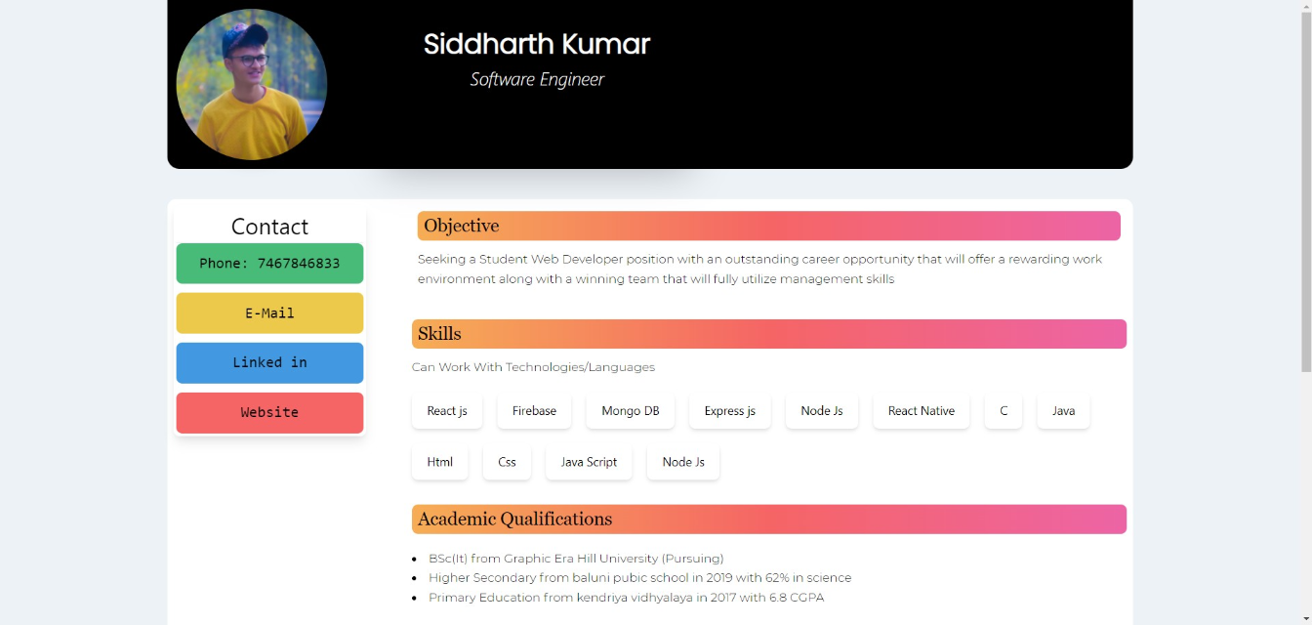

**NAME** – Siddharth Kumar **Roll** **number**: 1922065

**COURSE**: - B. Sc(IT). **Subject** **code**: PBI-502

**SUBJECT**: Full Stack Development **Semester**-5th

**University** Id: 19051056

**PROBLEM STATEMENT - 2 :** Design a Mark sheet using appropriate HTML tags.

**OBJECTIVE :** To understand how to arrange the element in a HTML page for a desire output like a marksheet using basic tags and &nsbp for arranging the blank spaces.

**DESCRIPTION :**

**Tag used –**

<b> Bold tag used to make text bold.

<centre> Used to centre elements in html.

<div> Used to create a empty block in html

&nbsp; Used to insert empty spaces in html

**Source Code-**

<!DOCTYPE html><html> <head> <title>Marksheet </title> </head><body> <center> <img style=" width: 200px; height:200px; " src="https://upload.wikimedia.org/wikipedia/en/b/b6/Graphic_Era_Hill_University_Logo.png" alt="graphic era hill university"> </center> <center> <b> <h1>MARKSHEET</h1> <h2>GRAPHIC ERA HILL UNIVERSITY</h2> Society Area, Clement Town Dehradun=248002,Uttrakhand(INDIA)<br>www.gehu.ac.in <br><br><h4>STATEMENT OF MARKS(PROVISIONAL) </h4> BACHELOR OF SCIENCE (INFORMATION TECHNOLOGY) -IV SEMESTER EXAMINATION(2020-21) </b> </center> <br><b>Name of Student :</b>Siddharth Kumar &nbsp;&nbsp;&nbsp;&nbsp;&nbsp;&nbsp;&nbsp;&nbsp;&nbsp;&nbsp;&nbsp;&nbsp;&nbsp;&nbsp;&nbsp;&nbsp;&nbsp;&nbsp;&nbsp;&nbsp;&nbsp;&nbsp;&nbsp;&nbsp;&nbsp;&nbsp;&nbsp;&nbsp;&nbsp;&nbsp;&nbsp;&nbsp;&nbsp;&nbsp;&nbsp;&nbsp;&nbsp;&nbsp;&nbsp;&nbsp;&nbsp;&nbsp;&nbsp;&nbsp;&nbsp;&nbsp;&nbsp;&nbsp;&nbsp;&nbsp;&nbsp;&nbsp;&nbsp;&nbsp;&nbsp;&nbsp;&nbsp;&nbsp;&nbsp;&nbsp;&nbsp;&nbsp;&nbsp;&nbsp;&nbsp;&nbsp;&nbsp;&nbsp;&nbsp;&nbsp;&nbsp;&nbsp;&nbsp;&nbsp;&nbsp;&nbsp;&nbsp;&nbsp;&nbsp;&nbsp;&nbsp;&nbsp;&nbsp;&nbsp;&nbsp;&nbsp;&nbsp;&nbsp;&nbsp;&nbsp;&nbsp;&nbsp;&nbsp;&nbsp;&nbsp;&nbsp;&nbsp;&nbsp;&nbsp;&nbsp;&nbsp;&nbsp;&nbsp;&nbsp;&nbsp;&nbsp;&nbsp;&nbsp;&nbsp;&nbsp;&nbsp;&nbsp;&nbsp;&nbsp;&nbsp;&nbsp;&nbsp;&nbsp;&nbsp;&nbsp;&nbsp;&nbsp;&nbsp;&nbsp;&nbsp;&nbsp;&nbsp;&nbsp;&nbsp;&nbsp;&nbsp;&nbsp;&nbsp;&nbsp;&nbsp;&nbsp;&nbsp;&nbsp;&nbsp;&nbsp;&nbsp;&nbsp;&nbsp;&nbsp;&nbsp;&nbsp;&nbsp;&nbsp;&nbsp;&nbsp;&nbsp;&nbsp;&nbsp;&nbsp;&nbsp;&nbsp;&nbsp;&nbsp;&nbsp;&nbsp;&nbsp;&nbsp;&nbsp;&nbsp;&nbsp;&nbsp;&nbsp;&nbsp;&nbsp;&nbsp;&nbsp;&nbsp;&nbsp;&nbsp;&nbsp;&nbsp;&nbsp;&nbsp;&nbsp;&nbsp;&nbsp;&nbsp;&nbsp;&nbsp;&nbsp;&nbsp;&nbsp;&nbsp;&nbsp;&nbsp;&nbsp;&nbsp;&nbsp;&nbsp;&nbsp;&nbsp;&nbsp;&nbsp;&nbsp;&nbsp;&nbsp;&nbsp;&nbsp;&nbsp; <b>Enrolment No: </b>PV-D1922065<br><br>&nbsp;&nbsp;&nbsp;&nbsp;&nbsp;&nbsp;&nbsp;&nbsp;&nbsp;&nbsp;&nbsp;&nbsp;&nbsp;&nbsp;&nbsp;&nbsp;&nbsp;&nbsp;&nbsp;&nbsp;&nbsp;&nbsp;&nbsp;&nbsp;&nbsp;&nbsp;&nbsp;&nbsp;&nbsp;&nbsp;&nbsp;&nbsp;&nbsp;&nbsp;&nbsp;&nbsp;&nbsp;&nbsp;&nbsp;&nbsp;&nbsp;&nbsp;&nbsp;&nbsp;&nbsp;&nbsp;&nbsp;&nbsp;&nbsp;&nbsp;&nbsp;&nbsp;&nbsp;&nbsp;&nbsp;&nbsp;&nbsp;&nbsp;&nbsp;&nbsp;&nbsp;&nbsp;&nbsp;&nbsp;&nbsp;&nbsp;&nbsp;&nbsp;&nbsp;&nbsp;&nbsp;&nbsp;&nbsp;&nbsp;&nbsp;&nbsp;&nbsp;&nbsp;&nbsp;&nbsp;&nbsp;&nbsp;&nbsp;&nbsp;&nbsp;&nbsp;&nbsp;&nbsp;&nbsp;&nbsp;&nbsp;&nbsp;&nbsp;&nbsp;&nbsp;&nbsp;&nbsp;&nbsp;&nbsp;&nbsp;&nbsp;&nbsp;&nbsp;&nbsp;&nbsp;&nbsp;&nbsp;&nbsp;&nbsp;&nbsp;&nbsp;&nbsp;&nbsp;&nbsp;&nbsp;&nbsp;&nbsp;&nbsp;&nbsp;&nbsp;&nbsp;&nbsp;&nbsp;&nbsp;&nbsp;&nbsp;&nbsp;&nbsp;&nbsp;&nbsp;&nbsp;&nbsp;&nbsp;&nbsp;&nbsp;&nbsp;&nbsp;&nbsp;&nbsp;&nbsp;&nbsp;&nbsp;&nbsp;&nbsp;&nbsp;&nbsp;&nbsp;&nbsp;&nbsp;&nbsp;&nbsp;&nbsp;&nbsp;&nbsp;&nbsp;&nbsp;&nbsp;&nbsp;&nbsp;&nbsp;&nbsp;&nbsp;&nbsp;&nbsp;&nbsp;&nbsp;&nbsp;&nbsp;&nbsp;&nbsp;&nbsp;&nbsp;&nbsp;&nbsp;&nbsp;&nbsp;&nbsp;&nbsp;&nbsp;&nbsp;&nbsp;&nbsp;&nbsp;&nbsp;&nbsp;&nbsp;&nbsp;&nbsp;&nbsp;&nbsp;&nbsp;&nbsp;&nbsp;&nbsp;&nbsp;&nbsp;&nbsp;&nbsp; <b>Roll No :</b>1922065<br><br><div> <b> &nbsp;&nbsp;&nbsp;&nbsp;&nbsp;&nbsp;&nbsp;&nbsp;&nbsp;&nbsp;&nbsp;&nbsp;&nbsp;&nbsp;&nbsp; SUBJECT &nbsp;&nbsp;&nbsp;&nbsp;&nbsp;&nbsp;&nbsp;&nbsp;&nbsp;&nbsp;&nbsp;&nbsp;&nbsp;&nbsp;&nbsp; &nbsp;&nbsp;&nbsp;&nbsp;&nbsp;&nbsp;&nbsp;&nbsp;&nbsp;&nbsp;&nbsp;&nbsp;&nbsp;&nbsp;&nbsp;&nbsp;&nbsp;&nbsp;&nbsp;&nbsp;&nbsp;&nbsp;&nbsp;&nbsp;&nbsp;&nbsp;&nbsp;&nbsp;&nbsp;&nbsp; &nbsp;&nbsp;&nbsp;&nbsp;&nbsp;&nbsp;&nbsp;&nbsp;&nbsp;&nbsp;&nbsp;&nbsp;&nbsp;&nbsp;&nbsp; CREDITS &nbsp;&nbsp;&nbsp;&nbsp;&nbsp;&nbsp;&nbsp;&nbsp;&nbsp;&nbsp;&nbsp;&nbsp;&nbsp;&nbsp;&nbsp; SESSIONAL MARKS &nbsp;&nbsp;&nbsp;&nbsp;&nbsp;&nbsp;&nbsp;&nbsp;&nbsp;&nbsp;&nbsp;&nbsp;&nbsp;&nbsp;&nbsp; END SEM MARKS &nbsp;&nbsp;&nbsp;&nbsp;&nbsp;&nbsp;&nbsp;&nbsp;&nbsp;&nbsp;&nbsp;&nbsp;&nbsp;&nbsp;&nbsp; TOTAL MARKS OBTAINED &nbsp;&nbsp;&nbsp;&nbsp;&nbsp;&nbsp;&nbsp;&nbsp;&nbsp;&nbsp;&nbsp;&nbsp;&nbsp;&nbsp;&nbsp; GRADE &nbsp;&nbsp;&nbsp;&nbsp;&nbsp;&nbsp;&nbsp;&nbsp;&nbsp;&nbsp;&nbsp;&nbsp;&nbsp;&nbsp;&nbsp; </b> </div><div> <b> CODE &nbsp;&nbsp;&nbsp;&nbsp;&nbsp;&nbsp;&nbsp;&nbsp;&nbsp;&nbsp;&nbsp;&nbsp;&nbsp;&nbsp;&nbsp;&nbsp;&nbsp;&nbsp;&nbsp;&nbsp;&nbsp;&nbsp; NAME &nbsp;&nbsp;&nbsp;&nbsp;&nbsp;&nbsp;&nbsp;&nbsp;&nbsp;&nbsp;&nbsp;&nbsp;&nbsp;&nbsp;&nbsp;&nbsp;&nbsp;&nbsp;&nbsp;&nbsp;&nbsp;&nbsp;&nbsp;&nbsp;&nbsp;&nbsp;&nbsp;&nbsp;&nbsp;&nbsp;&nbsp;&nbsp;&nbsp;&nbsp;&nbsp;&nbsp;&nbsp;&nbsp;&nbsp;&nbsp;&nbsp;&nbsp;&nbsp;&nbsp;&nbsp;&nbsp;&nbsp;&nbsp;&nbsp;&nbsp;&nbsp;&nbsp;&nbsp;&nbsp;&nbsp;&nbsp;&nbsp;&nbsp;&nbsp;&nbsp;&nbsp;&nbsp;&nbsp;&nbsp;&nbsp;&nbsp;&nbsp;&nbsp;&nbsp;&nbsp;&nbsp;&nbsp;&nbsp;&nbsp;&nbsp;&nbsp;&nbsp;&nbsp;&nbsp;&nbsp;&nbsp;&nbsp;&nbsp;&nbsp;&nbsp;&nbsp;&nbsp;&nbsp;&nbsp;&nbsp; MAX. &nbsp;&nbsp;&nbsp;&nbsp;&nbsp;&nbsp;&nbsp;&nbsp;&nbsp; OBT. &nbsp;&nbsp;&nbsp;&nbsp;&nbsp;&nbsp;&nbsp;&nbsp;&nbsp;&nbsp;&nbsp;&nbsp;&nbsp;&nbsp;&nbsp;&nbsp;&nbsp;&nbsp; MAX. &nbsp;&nbsp;&nbsp;&nbsp;&nbsp;&nbsp;&nbsp;&nbsp;&nbsp; OBT. &nbsp;&nbsp;&nbsp;&nbsp;&nbsp;&nbsp;&nbsp;&nbsp;&nbsp;&nbsp;&nbsp;&nbsp;&nbsp;&nbsp;&nbsp;&nbsp;&nbsp;&nbsp; <br></b> TBI401 &nbsp;&nbsp;&nbsp;&nbsp;&nbsp;&nbsp;&nbsp;&nbsp;&nbsp;&nbsp;&nbsp;&nbsp;&nbsp;&nbsp;&nbsp;&nbsp;&nbsp;&nbsp;&nbsp;&nbsp;&nbsp; Java Programming &nbsp;&nbsp;&nbsp;&nbsp;&nbsp;&nbsp;&nbsp;&nbsp;&nbsp;&nbsp;&nbsp;&nbsp;&nbsp;&nbsp;&nbsp;&nbsp;&nbsp;&nbsp;&nbsp;&nbsp;&nbsp;&nbsp;&nbsp;&nbsp;&nbsp;&nbsp;&nbsp;&nbsp;&nbsp;&nbsp;&nbsp;&nbsp;&nbsp;&nbsp;&nbsp;&nbsp; 4 &nbsp;&nbsp;&nbsp;&nbsp;&nbsp;&nbsp;&nbsp;&nbsp;&nbsp;&nbsp;&nbsp;&nbsp;&nbsp;&nbsp;&nbsp;&nbsp;&nbsp;&nbsp;&nbsp;&nbsp;&nbsp;&nbsp;&nbsp;&nbsp;&nbsp;&nbsp;&nbsp;&nbsp;&nbsp;&nbsp;&nbsp;&nbsp;&nbsp;&nbsp;&nbsp;&nbsp; 25 &nbsp;&nbsp;&nbsp;&nbsp;&nbsp;&nbsp;&nbsp;&nbsp;&nbsp;&nbsp;&nbsp;&nbsp;&nbsp;&nbsp;&nbsp; 23 &nbsp;&nbsp;&nbsp;&nbsp;&nbsp;&nbsp;&nbsp;&nbsp;&nbsp;&nbsp;&nbsp;&nbsp;&nbsp;&nbsp;&nbsp;&nbsp;&nbsp;&nbsp;&nbsp;&nbsp;&nbsp;&nbsp;&nbsp;&nbsp; 50 &nbsp;&nbsp;&nbsp;&nbsp;&nbsp;&nbsp;&nbsp;&nbsp;&nbsp;&nbsp;&nbsp;&nbsp;&nbsp;&nbsp;&nbsp; 40 &nbsp;&nbsp;&nbsp;&nbsp;&nbsp;&nbsp;&nbsp;&nbsp;&nbsp;&nbsp;&nbsp;&nbsp;&nbsp;&nbsp;&nbsp;&nbsp;&nbsp;&nbsp;&nbsp;&nbsp;&nbsp; &nbsp;&nbsp;&nbsp;&nbsp;&nbsp;&nbsp;&nbsp;&nbsp;&nbsp;&nbsp;&nbsp;&nbsp;&nbsp;&nbsp;&nbsp;&nbsp;&nbsp;&nbsp; 86 &nbsp;&nbsp;&nbsp;&nbsp;&nbsp;&nbsp;&nbsp;&nbsp;&nbsp;&nbsp;&nbsp;&nbsp;&nbsp;&nbsp;&nbsp;&nbsp;&nbsp;&nbsp; &nbsp;&nbsp;&nbsp;&nbsp;&nbsp;&nbsp;&nbsp;&nbsp;&nbsp;&nbsp;&nbsp;&nbsp;&nbsp;&nbsp;&nbsp;&nbsp;&nbsp;&nbsp;&nbsp;&nbsp;&nbsp; &nbsp;&nbsp;&nbsp;&nbsp;&nbsp;&nbsp; O <br><br>TBI402 &nbsp;&nbsp;&nbsp;&nbsp;&nbsp;&nbsp;&nbsp;&nbsp;&nbsp;&nbsp;&nbsp;&nbsp;&nbsp;&nbsp;&nbsp;&nbsp;&nbsp;&nbsp;&nbsp;&nbsp;&nbsp; Computer Based Numerical and <br>&nbsp;&nbsp;&nbsp;&nbsp;&nbsp;&nbsp;&nbsp;&nbsp;&nbsp;&nbsp;&nbsp;&nbsp;&nbsp;&nbsp;&nbsp;&nbsp;&nbsp;&nbsp;&nbsp;&nbsp;&nbsp;&nbsp;&nbsp;&nbsp;&nbsp;&nbsp;&nbsp;&nbsp;&nbsp;&nbsp;&nbsp;&nbsp;&nbsp;&nbsp;&nbsp; Statistical Techniques &nbsp;&nbsp;&nbsp;&nbsp;&nbsp;&nbsp;&nbsp;&nbsp;&nbsp;&nbsp;&nbsp;&nbsp;&nbsp;&nbsp;&nbsp;&nbsp;&nbsp;&nbsp;&nbsp;&nbsp;&nbsp;&nbsp;&nbsp;&nbsp;&nbsp;&nbsp;&nbsp;&nbsp;&nbsp;&nbsp;&nbsp; 3 &nbsp;&nbsp;&nbsp;&nbsp;&nbsp;&nbsp;&nbsp;&nbsp;&nbsp;&nbsp;&nbsp;&nbsp;&nbsp;&nbsp;&nbsp;&nbsp;&nbsp;&nbsp;&nbsp;&nbsp;&nbsp;&nbsp;&nbsp;&nbsp;&nbsp;&nbsp;&nbsp;&nbsp;&nbsp;&nbsp;&nbsp;&nbsp;&nbsp;&nbsp;&nbsp;&nbsp; 25 &nbsp;&nbsp;&nbsp;&nbsp;&nbsp;&nbsp;&nbsp;&nbsp;&nbsp;&nbsp;&nbsp;&nbsp;&nbsp;&nbsp;&nbsp; 19 &nbsp;&nbsp;&nbsp;&nbsp;&nbsp;&nbsp;&nbsp;&nbsp;&nbsp;&nbsp;&nbsp;&nbsp;&nbsp;&nbsp;&nbsp;&nbsp;&nbsp;&nbsp;&nbsp;&nbsp;&nbsp;&nbsp;&nbsp;&nbsp; 50 &nbsp;&nbsp;&nbsp;&nbsp;&nbsp;&nbsp;&nbsp;&nbsp;&nbsp;&nbsp;&nbsp;&nbsp;&nbsp;&nbsp;&nbsp; 35 &nbsp;&nbsp;&nbsp;&nbsp;&nbsp;&nbsp;&nbsp;&nbsp;&nbsp;&nbsp;&nbsp;&nbsp;&nbsp;&nbsp;&nbsp;&nbsp;&nbsp;&nbsp;&nbsp;&nbsp;&nbsp; &nbsp;&nbsp;&nbsp;&nbsp;&nbsp;&nbsp;&nbsp;&nbsp;&nbsp;&nbsp;&nbsp;&nbsp;&nbsp;&nbsp;&nbsp;&nbsp;&nbsp;&nbsp; 71 &nbsp;&nbsp;&nbsp;&nbsp;&nbsp;&nbsp;&nbsp;&nbsp;&nbsp;&nbsp;&nbsp;&nbsp;&nbsp;&nbsp;&nbsp;&nbsp;&nbsp;&nbsp; &nbsp;&nbsp;&nbsp;&nbsp;&nbsp;&nbsp;&nbsp;&nbsp;&nbsp;&nbsp;&nbsp;&nbsp;&nbsp;&nbsp;&nbsp;&nbsp;&nbsp;&nbsp;&nbsp;&nbsp;&nbsp; &nbsp;&nbsp;&nbsp;&nbsp;&nbsp;&nbsp; A <br><br>TBI403 &nbsp;&nbsp;&nbsp;&nbsp;&nbsp;&nbsp;&nbsp;&nbsp;&nbsp;&nbsp;&nbsp;&nbsp;&nbsp;&nbsp;&nbsp;&nbsp;&nbsp;&nbsp;&nbsp;&nbsp;&nbsp; Computer Organisation and <br>&nbsp;&nbsp;&nbsp;&nbsp;&nbsp;&nbsp;&nbsp;&nbsp;&nbsp;&nbsp;&nbsp;&nbsp;&nbsp;&nbsp;&nbsp;&nbsp;&nbsp;&nbsp;&nbsp;&nbsp;&nbsp;&nbsp;&nbsp;&nbsp;&nbsp;&nbsp;&nbsp;&nbsp;&nbsp;&nbsp;&nbsp;&nbsp;&nbsp;&nbsp;&nbsp;&nbsp;Architecture &nbsp;&nbsp;&nbsp;&nbsp;&nbsp;&nbsp;&nbsp;&nbsp;&nbsp;&nbsp;&nbsp;&nbsp;&nbsp;&nbsp;&nbsp;&nbsp;&nbsp;&nbsp;&nbsp;&nbsp;&nbsp;&nbsp;&nbsp;&nbsp;&nbsp;&nbsp;&nbsp;&nbsp;&nbsp;&nbsp;&nbsp;&nbsp;&nbsp;&nbsp;&nbsp;&nbsp;&nbsp;&nbsp;&nbsp;&nbsp;&nbsp;&nbsp;&nbsp;&nbsp;&nbsp;&nbsp; 3 &nbsp;&nbsp;&nbsp;&nbsp;&nbsp;&nbsp;&nbsp;&nbsp;&nbsp;&nbsp;&nbsp;&nbsp;&nbsp;&nbsp;&nbsp;&nbsp;&nbsp;&nbsp;&nbsp;&nbsp;&nbsp;&nbsp;&nbsp;&nbsp;&nbsp;&nbsp;&nbsp;&nbsp;&nbsp;&nbsp;&nbsp;&nbsp;&nbsp;&nbsp;&nbsp;&nbsp; 25 &nbsp;&nbsp;&nbsp;&nbsp;&nbsp;&nbsp;&nbsp;&nbsp;&nbsp;&nbsp;&nbsp;&nbsp;&nbsp;&nbsp;&nbsp; 23 &nbsp;&nbsp;&nbsp;&nbsp;&nbsp;&nbsp;&nbsp;&nbsp;&nbsp;&nbsp;&nbsp;&nbsp;&nbsp;&nbsp;&nbsp;&nbsp;&nbsp;&nbsp;&nbsp;&nbsp;&nbsp;&nbsp;&nbsp;&nbsp; 50 &nbsp;&nbsp;&nbsp;&nbsp;&nbsp;&nbsp;&nbsp;&nbsp;&nbsp;&nbsp;&nbsp;&nbsp;&nbsp;&nbsp;&nbsp; 47 &nbsp;&nbsp;&nbsp;&nbsp;&nbsp;&nbsp;&nbsp;&nbsp;&nbsp;&nbsp;&nbsp;&nbsp;&nbsp;&nbsp;&nbsp;&nbsp;&nbsp;&nbsp;&nbsp;&nbsp;&nbsp; &nbsp;&nbsp;&nbsp;&nbsp;&nbsp;&nbsp;&nbsp;&nbsp;&nbsp;&nbsp;&nbsp;&nbsp;&nbsp;&nbsp;&nbsp;&nbsp;&nbsp;&nbsp; 93 &nbsp;&nbsp;&nbsp;&nbsp;&nbsp;&nbsp;&nbsp;&nbsp;&nbsp;&nbsp;&nbsp;&nbsp;&nbsp;&nbsp;&nbsp;&nbsp;&nbsp;&nbsp; &nbsp;&nbsp;&nbsp;&nbsp;&nbsp;&nbsp;&nbsp;&nbsp;&nbsp;&nbsp;&nbsp;&nbsp;&nbsp;&nbsp;&nbsp;&nbsp;&nbsp;&nbsp;&nbsp;&nbsp;&nbsp; &nbsp;&nbsp;&nbsp;&nbsp;&nbsp;&nbsp; O <br><br>TBI404 &nbsp;&nbsp;&nbsp;&nbsp;&nbsp;&nbsp;&nbsp;&nbsp;&nbsp;&nbsp;&nbsp;&nbsp;&nbsp;&nbsp;&nbsp;&nbsp;&nbsp;&nbsp;&nbsp;&nbsp;&nbsp; Cryptography &nbsp;&nbsp;&nbsp;&nbsp;&nbsp;&nbsp;&nbsp;&nbsp;&nbsp;&nbsp;&nbsp;&nbsp;&nbsp;&nbsp;&nbsp;&nbsp;&nbsp;&nbsp;&nbsp;&nbsp;&nbsp;&nbsp;&nbsp;&nbsp;&nbsp;&nbsp;&nbsp;&nbsp;&nbsp;&nbsp;&nbsp;&nbsp;&nbsp;&nbsp;&nbsp;&nbsp;&nbsp;&nbsp;&nbsp;&nbsp;&nbsp;&nbsp;&nbsp;&nbsp; 3 &nbsp;&nbsp;&nbsp;&nbsp;&nbsp;&nbsp;&nbsp;&nbsp;&nbsp;&nbsp;&nbsp;&nbsp;&nbsp;&nbsp;&nbsp;&nbsp;&nbsp;&nbsp;&nbsp;&nbsp;&nbsp;&nbsp;&nbsp;&nbsp;&nbsp;&nbsp;&nbsp;&nbsp;&nbsp;&nbsp;&nbsp;&nbsp;&nbsp;&nbsp;&nbsp;&nbsp; 25 &nbsp;&nbsp;&nbsp;&nbsp;&nbsp;&nbsp;&nbsp;&nbsp;&nbsp;&nbsp;&nbsp;&nbsp;&nbsp;&nbsp;&nbsp; 19 &nbsp;&nbsp;&nbsp;&nbsp;&nbsp;&nbsp;&nbsp;&nbsp;&nbsp;&nbsp;&nbsp;&nbsp;&nbsp;&nbsp;&nbsp;&nbsp;&nbsp;&nbsp;&nbsp;&nbsp;&nbsp;&nbsp;&nbsp;&nbsp; 50 &nbsp;&nbsp;&nbsp;&nbsp;&nbsp;&nbsp;&nbsp;&nbsp;&nbsp;&nbsp;&nbsp;&nbsp;&nbsp;&nbsp;&nbsp; 40 &nbsp;&nbsp;&nbsp;&nbsp;&nbsp;&nbsp;&nbsp;&nbsp;&nbsp;&nbsp;&nbsp;&nbsp;&nbsp;&nbsp;&nbsp;&nbsp;&nbsp;&nbsp;&nbsp;&nbsp;&nbsp; &nbsp;&nbsp;&nbsp;&nbsp;&nbsp;&nbsp;&nbsp;&nbsp;&nbsp;&nbsp;&nbsp;&nbsp;&nbsp;&nbsp;&nbsp;&nbsp;&nbsp;&nbsp; 79 &nbsp;&nbsp;&nbsp;&nbsp;&nbsp;&nbsp;&nbsp;&nbsp;&nbsp;&nbsp;&nbsp;&nbsp;&nbsp;&nbsp;&nbsp;&nbsp;&nbsp;&nbsp; &nbsp;&nbsp;&nbsp;&nbsp;&nbsp;&nbsp;&nbsp;&nbsp;&nbsp;&nbsp;&nbsp;&nbsp;&nbsp;&nbsp;&nbsp;&nbsp;&nbsp;&nbsp;&nbsp;&nbsp;&nbsp; &nbsp;&nbsp;&nbsp;&nbsp;&nbsp;&nbsp; A+ <br><br>XBI401 &nbsp;&nbsp;&nbsp;&nbsp;&nbsp;&nbsp;&nbsp;&nbsp;&nbsp;&nbsp;&nbsp;&nbsp;&nbsp;&nbsp;&nbsp;&nbsp;&nbsp;&nbsp;&nbsp;&nbsp;&nbsp; Career Skills-II &nbsp;&nbsp;&nbsp;&nbsp; &nbsp;&nbsp;&nbsp;&nbsp;&nbsp;&nbsp;&nbsp;&nbsp;&nbsp;&nbsp;&nbsp;&nbsp;&nbsp;&nbsp;&nbsp;&nbsp;&nbsp;&nbsp;&nbsp;&nbsp;&nbsp;&nbsp;&nbsp;&nbsp;&nbsp;&nbsp;&nbsp;&nbsp;&nbsp;&nbsp;&nbsp;&nbsp;&nbsp;&nbsp;&nbsp;&nbsp; 2 &nbsp;&nbsp;&nbsp;&nbsp;&nbsp;&nbsp;&nbsp;&nbsp;&nbsp;&nbsp;&nbsp;&nbsp;&nbsp;&nbsp;&nbsp;&nbsp;&nbsp;&nbsp;&nbsp;&nbsp;&nbsp;&nbsp;&nbsp;&nbsp;&nbsp;&nbsp;&nbsp;&nbsp;&nbsp;&nbsp;&nbsp;&nbsp;&nbsp;&nbsp;&nbsp;&nbsp; 25 &nbsp;&nbsp;&nbsp;&nbsp;&nbsp;&nbsp;&nbsp;&nbsp;&nbsp;&nbsp;&nbsp;&nbsp;&nbsp;&nbsp;&nbsp; 12 &nbsp;&nbsp;&nbsp;&nbsp;&nbsp;&nbsp;&nbsp;&nbsp;&nbsp;&nbsp;&nbsp;&nbsp;&nbsp;&nbsp;&nbsp;&nbsp;&nbsp;&nbsp;&nbsp;&nbsp;&nbsp;&nbsp;&nbsp;&nbsp; 50 &nbsp;&nbsp;&nbsp;&nbsp;&nbsp;&nbsp;&nbsp;&nbsp;&nbsp;&nbsp;&nbsp;&nbsp;&nbsp;&nbsp;&nbsp; 24 &nbsp;&nbsp;&nbsp;&nbsp;&nbsp;&nbsp;&nbsp;&nbsp;&nbsp;&nbsp;&nbsp;&nbsp;&nbsp;&nbsp;&nbsp;&nbsp;&nbsp;&nbsp;&nbsp;&nbsp;&nbsp; &nbsp;&nbsp;&nbsp;&nbsp;&nbsp;&nbsp;&nbsp;&nbsp;&nbsp;&nbsp;&nbsp;&nbsp;&nbsp;&nbsp;&nbsp;&nbsp;&nbsp;&nbsp; 57 &nbsp;&nbsp;&nbsp;&nbsp;&nbsp;&nbsp;&nbsp;&nbsp;&nbsp;&nbsp;&nbsp;&nbsp;&nbsp;&nbsp;&nbsp;&nbsp;&nbsp;&nbsp; &nbsp;&nbsp;&nbsp;&nbsp;&nbsp;&nbsp;&nbsp;&nbsp;&nbsp;&nbsp;&nbsp;&nbsp;&nbsp;&nbsp;&nbsp;&nbsp;&nbsp;&nbsp;&nbsp;&nbsp;&nbsp; &nbsp;&nbsp;&nbsp;&nbsp;&nbsp;&nbsp; B+ <br><br>GE401 &nbsp;&nbsp;&nbsp;&nbsp;&nbsp;&nbsp;&nbsp;&nbsp;&nbsp;&nbsp;&nbsp;&nbsp;&nbsp;&nbsp;&nbsp;&nbsp;&nbsp;&nbsp;&nbsp;&nbsp;&nbsp; Film Appreciation &nbsp;&nbsp;&nbsp;&nbsp;&nbsp;&nbsp;&nbsp;&nbsp;&nbsp;&nbsp;&nbsp;&nbsp;&nbsp;&nbsp;&nbsp;&nbsp;&nbsp;&nbsp;&nbsp;&nbsp;&nbsp;&nbsp;&nbsp;&nbsp;&nbsp;&nbsp;&nbsp;&nbsp;&nbsp;&nbsp;&nbsp;&nbsp;&nbsp;&nbsp;&nbsp;&nbsp;&nbsp;&nbsp; 4 &nbsp;&nbsp;&nbsp;&nbsp;&nbsp;&nbsp;&nbsp;&nbsp;&nbsp;&nbsp;&nbsp;&nbsp;&nbsp;&nbsp;&nbsp;&nbsp;&nbsp;&nbsp;&nbsp;&nbsp;&nbsp;&nbsp;&nbsp;&nbsp;&nbsp;&nbsp;&nbsp;&nbsp;&nbsp;&nbsp;&nbsp;&nbsp;&nbsp;&nbsp;&nbsp;&nbsp; 25 &nbsp;&nbsp;&nbsp;&nbsp;&nbsp;&nbsp;&nbsp;&nbsp;&nbsp;&nbsp;&nbsp;&nbsp;&nbsp;&nbsp;&nbsp; 20 &nbsp;&nbsp;&nbsp;&nbsp;&nbsp;&nbsp;&nbsp;&nbsp;&nbsp;&nbsp;&nbsp;&nbsp;&nbsp;&nbsp;&nbsp;&nbsp;&nbsp;&nbsp;&nbsp;&nbsp;&nbsp;&nbsp;&nbsp;&nbsp; 50 &nbsp;&nbsp;&nbsp;&nbsp;&nbsp;&nbsp;&nbsp;&nbsp;&nbsp;&nbsp;&nbsp;&nbsp;&nbsp;&nbsp;&nbsp; 40 &nbsp;&nbsp;&nbsp;&nbsp;&nbsp;&nbsp;&nbsp;&nbsp;&nbsp;&nbsp;&nbsp;&nbsp;&nbsp;&nbsp;&nbsp;&nbsp;&nbsp;&nbsp;&nbsp;&nbsp;&nbsp; &nbsp;&nbsp;&nbsp;&nbsp;&nbsp;&nbsp;&nbsp;&nbsp;&nbsp;&nbsp;&nbsp;&nbsp;&nbsp;&nbsp;&nbsp;&nbsp;&nbsp;&nbsp; 82 &nbsp;&nbsp;&nbsp;&nbsp;&nbsp;&nbsp;&nbsp;&nbsp;&nbsp;&nbsp;&nbsp;&nbsp;&nbsp;&nbsp;&nbsp;&nbsp;&nbsp;&nbsp; &nbsp;&nbsp;&nbsp;&nbsp;&nbsp;&nbsp;&nbsp;&nbsp;&nbsp;&nbsp;&nbsp;&nbsp;&nbsp;&nbsp;&nbsp;&nbsp;&nbsp;&nbsp;&nbsp;&nbsp;&nbsp; &nbsp;&nbsp;&nbsp;&nbsp;&nbsp;&nbsp; O <br><br></div></center> <br><br><br><div> <b> Result :&nbsp;&nbsp;&nbsp;&nbsp;&nbsp;&nbsp;&nbsp;&nbsp;&nbsp;&nbsp;&nbsp;&nbsp;&nbsp;&nbsp;&nbsp;&nbsp;&nbsp;&nbsp;&nbsp;&nbsp;&nbsp;&nbsp;&nbsp;&nbsp;&nbsp;&nbsp;&nbsp;&nbsp;&nbsp;&nbsp;&nbsp;&nbsp;&nbsp;&nbsp;&nbsp;&nbsp;&nbsp;&nbsp;&nbsp;&nbsp;&nbsp;&nbsp; &nbsp;&nbsp;&nbsp;&nbsp;&nbsp;&nbsp;&nbsp;&nbsp;&nbsp;PASS <br><br>Total NO. of Credits Registered: &nbsp;&nbsp;&nbsp;&nbsp;&nbsp;&nbsp;&nbsp;&nbsp;&nbsp;25 <br><br>Total NO. of Credits Earned :&nbsp;&nbsp;&nbsp;&nbsp;&nbsp;&nbsp;&nbsp;&nbsp;&nbsp;&nbsp;&nbsp;&nbsp;&nbsp;&nbsp;25 <br><br>SGPA:&nbsp;&nbsp;&nbsp;&nbsp;&nbsp;&nbsp;&nbsp;&nbsp;&nbsp;&nbsp;&nbsp;&nbsp;&nbsp;&nbsp;&nbsp;&nbsp;&nbsp;&nbsp;&nbsp; &nbsp;&nbsp;&nbsp;&nbsp;&nbsp;&nbsp;&nbsp;&nbsp;&nbsp;&nbsp;&nbsp;&nbsp;&nbsp;&nbsp;&nbsp;&nbsp;&nbsp;&nbsp;&nbsp;&nbsp;&nbsp;&nbsp;&nbsp;&nbsp;&nbsp;&nbsp;&nbsp;&nbsp;&nbsp;&nbsp;&nbsp;&nbsp;&nbsp;9.2 <br><br>CGPA: <br></b> </div></body> </html>

**Output-**

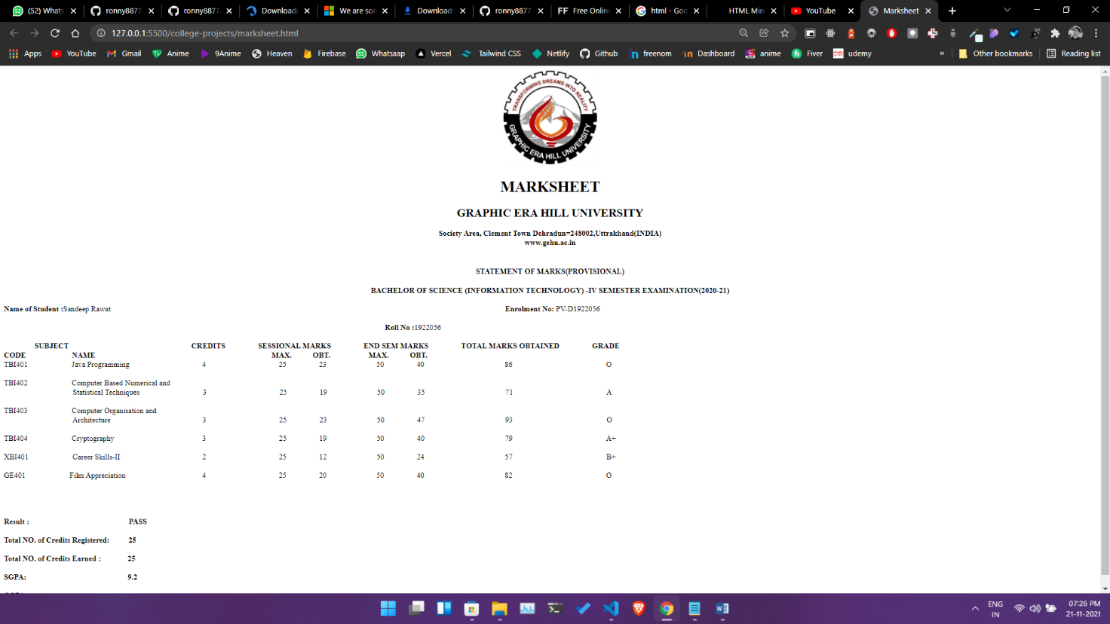

**NAME** – Siddharth Kumar **Roll** **number**: 1922065

**COURSE**: - B. Sc(IT). **Subject** **code**: PBI-502

**SUBJECT**: Full Stack Development **Semester**-5th

**University** Id: 19051056

**PROBLEM STATEMENT - 4 :** Write a HTML code to draw figure (Hut).

**OBJECTIVE :** To understand the use of pre tag for making a specific figure like a hut.

**DESCRIPTION :**

**Tag used –**

<pre>: Used to render item as it is in html

**Output**

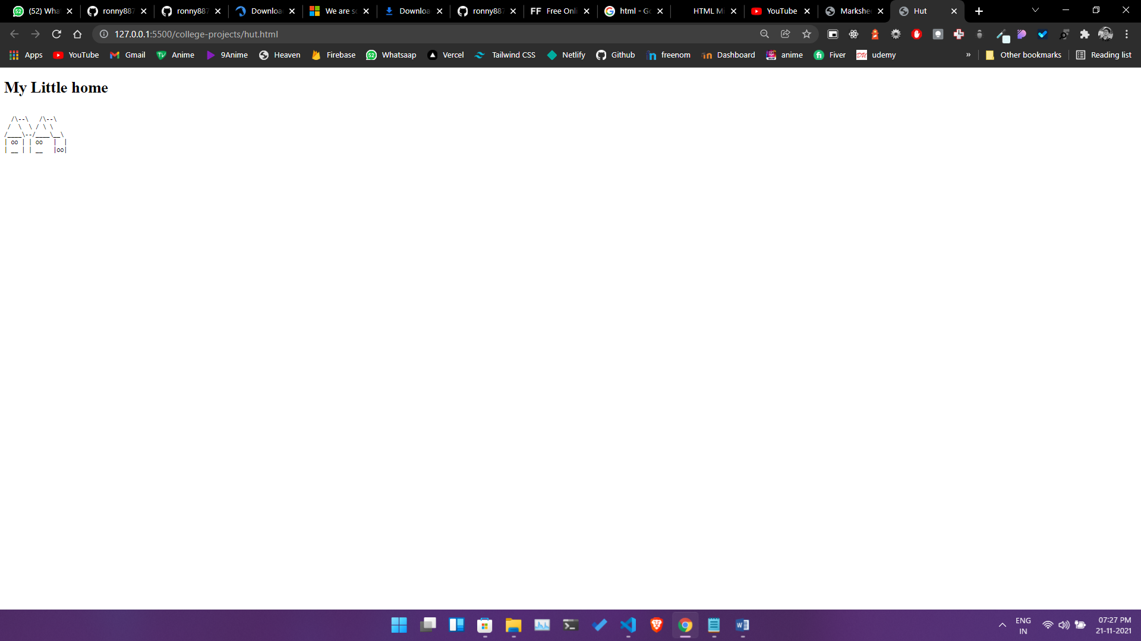

**NAME** – Siddharth Kumar **Roll** **number**: 1922065

**COURSE**: - B. Sc(IT). **Subject** **code**: PBI-502

**SUBJECT**: Full Stack Development **Semester**-5th

**University** Id: 19051056

**PROBLEM STATEMENT - 3 :** To create a web page in HTML to show the Block Level Elements and Text Level Elements.

**OBJECTIVE :** To understand block level elements bold italics underline and how to use formatting tags to format the html document and use font tag for applying different styles and colour to an html text.

**DESCRIPTION :**

**Tag used –**

<>: Tags used are defined in the document.

<!DOCTYPE html>

<html lang="en">

<head>

<meta charset="UTF-8">

<meta http-equiv="X-UA-Compatible" content="IE=edge">

<meta name="viewport" content="width=device-width, initial-scale=1.0">

<title>Block Elements</title>

<style>

.container {

text-align: center;

max-width: 960px;

padding: 0 15px;

height: auto;

margin: 0 auto;

border-radius: 2.5rem;

background: #ffffff;

box-shadow: 7px 7px 14px #b3b3b3,

-7px -7px 14px #ffffff;

}

.container h1{

text-decoration: line-through;

color:red;

}

.container h3{

color:palevioletred ;

}

</style>

</head>

<body style="background-color:#F6F6F6">

<div class="container">

<br />

<h1>Block Level Elements</h1>

<h3>

< P> tag

</h3>

<p>

Non elit duis laboris magna id. Consectetur occaecat sint magna mollit. Nulla tempor sit sint et in ad

mollit magna ullamco ex enim est occaecat exercitation. Ullamco dolor velit minim mollit officia mollit

ullamco pariatur ipsum magna. Occaecat laborum magna ex duis ullamco proident.

</p>

<br />

<h3>

< b> Tag

</h3>

<b>Minim deserunt anim nulla id cupidatat excepteur dolore anim aute tempor magna nisi. Reprehenderit aute

adipisicing ex nostrud excepteur id anim commodo exercitation incididunt aliqua Lorem ex. Esse elit ex sint

sunt deserunt excepteur eu. Excepteur consequat tempor esse voluptate velit mollit eiusmod exercitation qui.

Officia amet veniam occaecat aliquip dolore dolor sunt occaecat esse amet esse.</b>

<br />

<h3>

< i> Tag

</h3>

<i>Minim deserunt anim nulla id cupidatat excepteur dolore anim aute tempor magna nisi. Reprehenderit aute

adipisicing ex nostrud excepteur id anim commodo exercitation incididunt aliqua Lorem ex. Esse elit ex sint

sunt deserunt excepteur eu. Excepteur consequat tempor esse voluptate velit mollit eiusmod exercitation qui.

Officia amet veniam occaecat aliquip dolore dolor sunt occaecat esse amet esse.</i>

<br />

<h3>

< ins > Tag

</h3>

<ins>Minim deserunt anim nulla id cupidatat excepteur dolore anim aute tempor magna nisi. Reprehenderit aute

adipisicing ex nostrud excepteur id anim commodo exercitation incididunt aliqua Lorem ex. Esse elit ex sint

sunt deserunt excepteur eu. Excepteur consequat tempor esse voluptate velit mollit eiusmod exercitation qui.

Officia amet veniam occaecat aliquip dolore dolor sunt occaecat esse amet esse.</ins>

<br />

<h3>

< del > Tag

</h3>

<del>Minim deserunt anim nulla id cupidatat excepteur dolore anim aute tempor magna nisi. Reprehenderit aute

adipisicing ex nostrud excepteur id anim commodo exercitation incididunt aliqua Lorem ex. Esse elit ex sint

sunt deserunt excepteur eu. Excepteur consequat tempor esse voluptate velit mollit eiusmod exercitation qui.

Officia amet veniam occaecat aliquip dolore dolor sunt occaecat esse amet esse.</del>

<br />

<h3>

< dfn > Tag

</h3>

<dfn>Minim deserunt anim nulla id cupidatat excepteur dolore anim aute tempor magna nisi. Reprehenderit aute

adipisicing ex nostrud excepteur id anim commodo exercitation incididunt aliqua Lorem ex. Esse elit ex sint

sunt deserunt excepteur eu. Excepteur consequat tempor esse voluptate velit mollit eiusmod exercitation qui.

Officia amet veniam occaecat aliquip dolore dolor sunt occaecat esse amet esse.</dfn>

<br />

<h3>

< article > Tag

</h3>

<artical>Minim deserunt anim nulla id cupidatat excepteur dolore anim aute tempor magna nisi. Reprehenderit aute

adipisicing ex nostrud excepteur id anim commodo exercitation incididunt aliqua Lorem ex. Esse elit ex sint

sunt deserunt excepteur eu. Excepteur consequat tempor esse voluptate velit mollit eiusmod exercitation qui.

Officia amet veniam occaecat aliquip dolore dolor sunt occaecat esse amet esse.</artical>

<br/>

<br/>

<br/>

</div>

</body></html>

**Output**

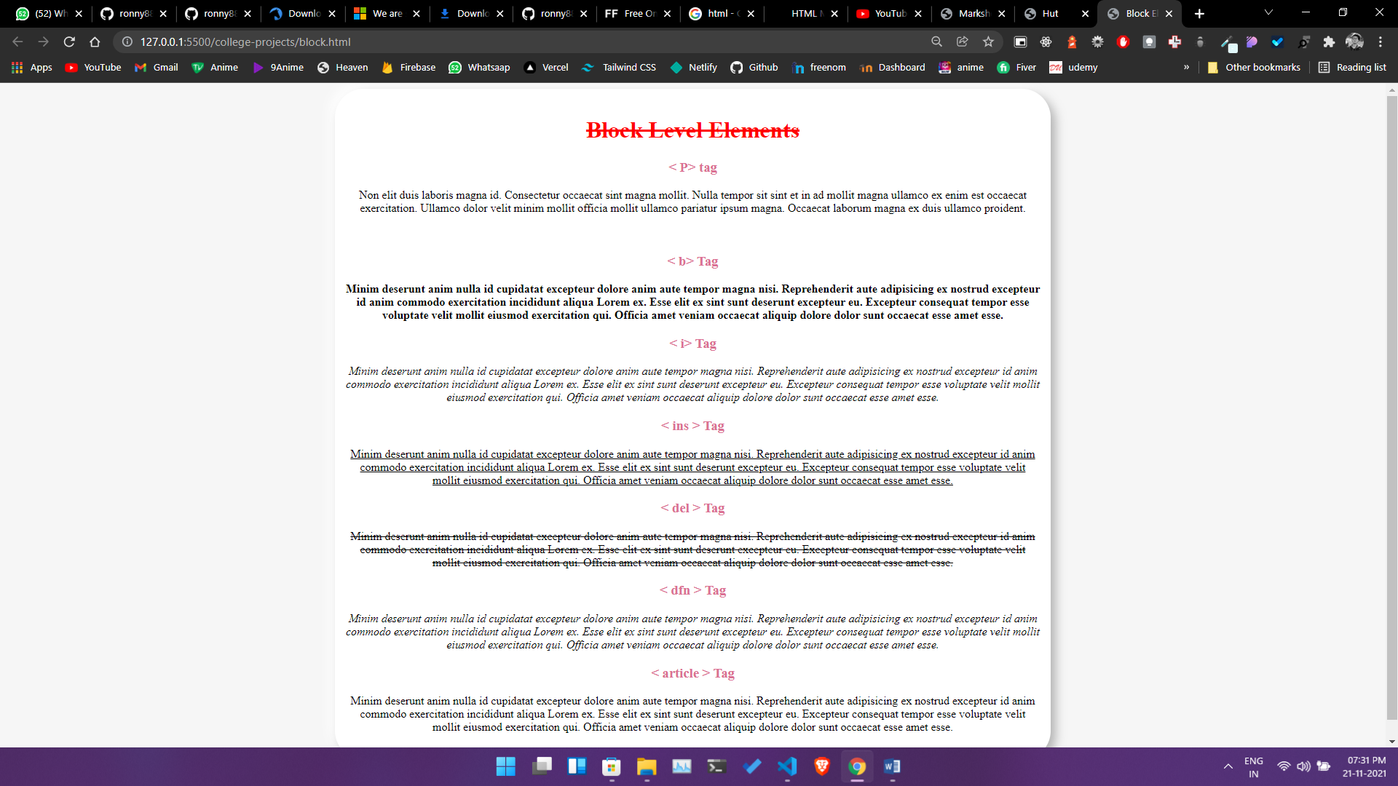

**NAME** – Siddharth Kumar **Roll** **number**: 1922065

**COURSE**: - B. Sc(IT). **Subject** **code**: PBI-502

**SUBJECT**: Full Stack Development **Semester**-5th

**University** Id: 19051056

**PROBLEM STATEMENT - 5 :** WAP in HTML to create a web page to show various confectionary items using ordered and unordered list.

**OBJECTIVE :** To understand the use of ordered and unordered list for making a list of items on webpage, these can be numbered or bulleted.

**DESCRIPTION :**

**Tag used –**

<ul>Used to create unordered list.

<ol> Used to create ordered list.

**Source Code-**

<!DOCTYPE html>

<html lang="en">

<head>

    <meta charset="UTF-8">

    <meta http-equiv="X-UA-Compatible" content="IE=edge">

    <meta name="viewport" content="width=device-width, initial-scale=1.0">

    <title>List</title>

    <link href="https://unpkg.com/tailwindcss@^1.0/dist/tailwind.min.css" rel="stylesheet">

</head>

<body>

    <div class="container m-auto text-center bg-gray-100">

        <h1 class="text-4xl m-3">Unordered List</h1>

        <ul class="list-disc flex flex-wrap flex-row gap-5" id="unorder"> </ul>

        <hr />

        <h1 class="text-4xl m-3">Ordered List</h1>

        <ol class="list-decimal flex flex-wrap flex-row gap-5" id="ordered">

            </ul>

            <hr />

    </div>

</body>

<script>

    var names = ["Cake", "Cookie", "Cupcake", "Donut", "Eclair", "Fruitcake", "Gingerbread", "Ice Cream", "Jelly",

        "Lollipop", "Marshmallow", "Nougat", "Oreo", "Pie", "Pudding", "Tart", "Wafer", "Waffle"

    ];

    //a function that return a list item with random name

    function getRandomName() {

        var randomName = names[Math.floor(Math.random() * names.length)];

        return randomName;

    }

    //a function to create a custom element

    function CustomElement(id, ele) {

        for (let i = 0; i < names.length; i++) {

            let listItem = document.createElement(ele && "li")

            listItem.innerHTML = getRandomName();

            listItem.classList.add("bg-red-500", "w-64", "h-48", "rounded-lg", "shadow-lg", "m-auto", "mt-5", "p-2",

                "text-center", "font-bold", "text-xl");

            document.getElementById(id).appendChild(listItem);

        }

    }

    CustomElement("unorder", "li");

    CustomElement("ordered", "li");

</script>

</html>

**Output**

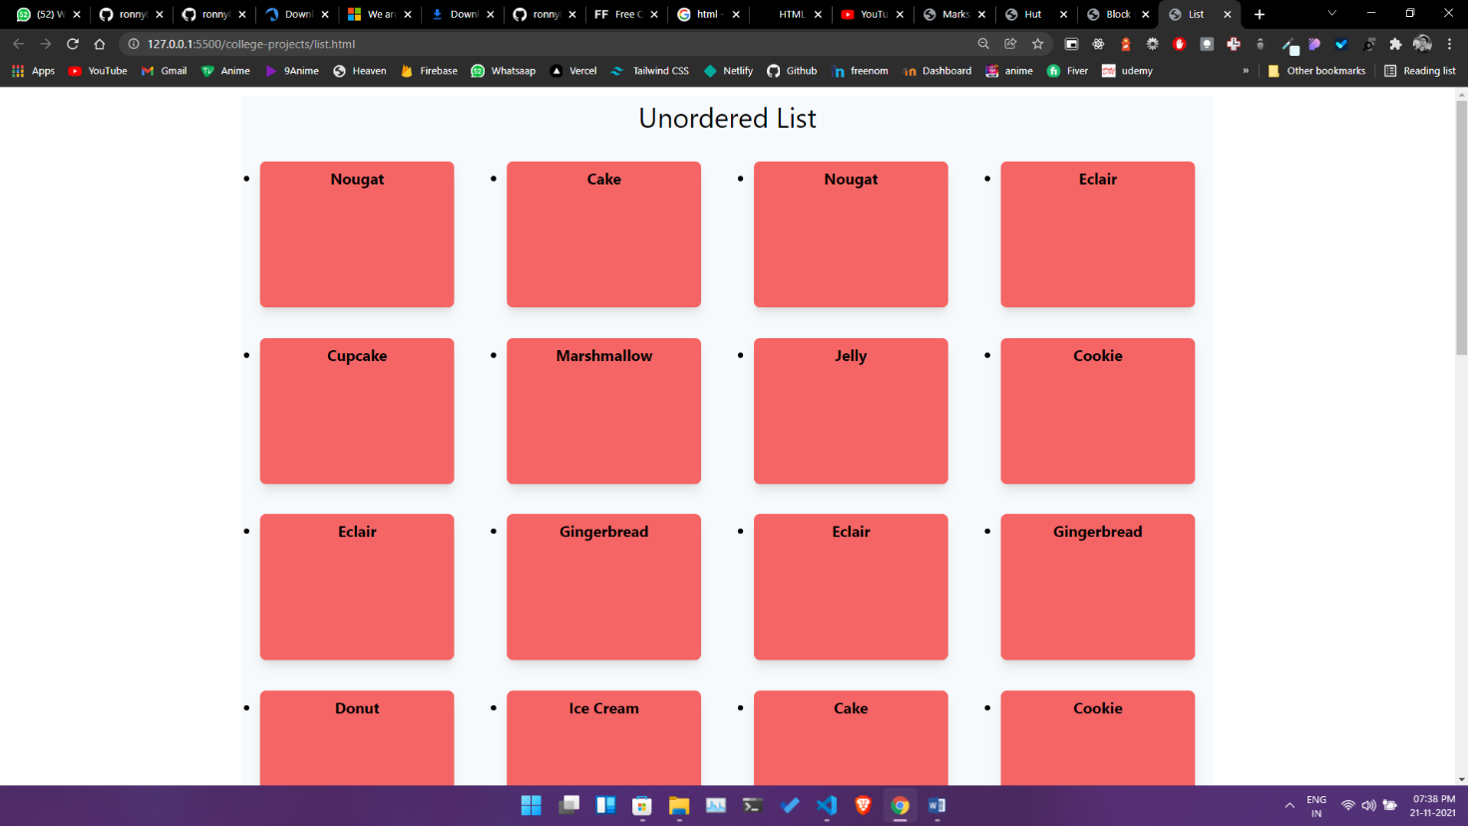

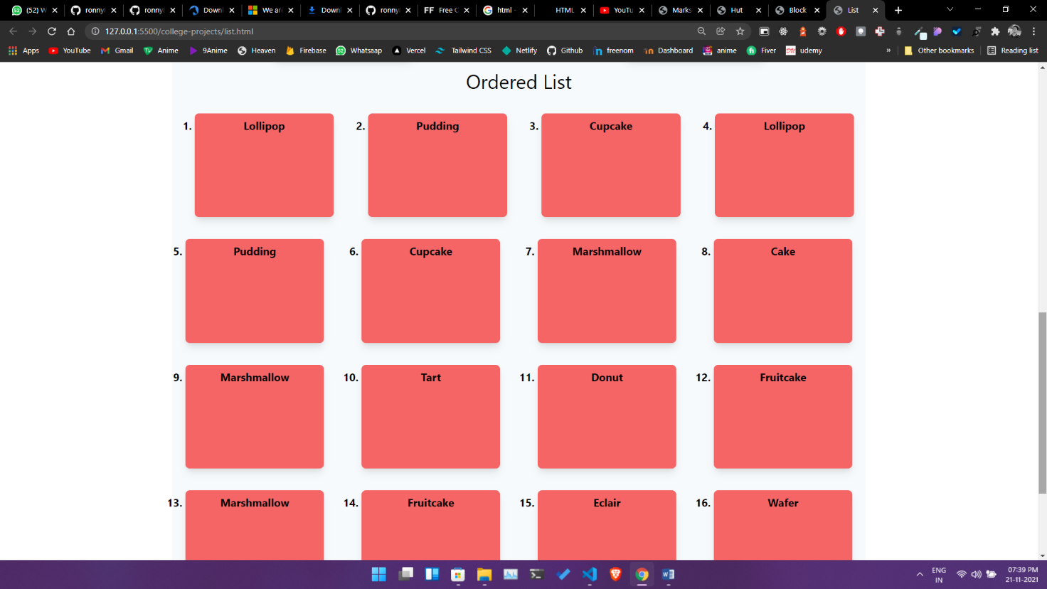

**NAME** – Siddharth Kumar **Roll** **number**: 1922065

**COURSE**: - B. Sc(IT). **Subject** **code**: PBI-502

**SUBJECT**: Full Stack Development **Semester**-5th

**University** Id: 19051056

**PROBLEM STATEMENT - 8 :** Write a HTML code to create a hyperlink from top of your page to the bottom of the same page.

**OBJECTIVE :** To understand the concept of linking page from top to bottom.

**DESCRIPTION :**

**Tag used –**

<a> Used to link documents either inside or outside of the page

**Source Code –**

<!DOCTYPE html>

<html lang="en">

<head>

    <meta charset="UTF-8">

    <meta http-equiv="X-UA-Compatible" content="IE=edge">

    <meta name="viewport" content="width=device-width, initial-scale=1.0">

    <title>Links</title>

    <link href="https://unpkg.com/tailwindcss@^1.0/dist/tailwind.min.css" rel="stylesheet">

</head>

<div class="container m-auto text-center">

    <h1 id="top" class="text-5xl"> Links</h1>

    <a class="text-xl text-blue-500" href="#end">Take me to end</a>

    <p class="text-lg mb-64 leading-10">

        Eu cupidatat nostrud labore ipsum minim cillum laboris nulla ut aliquip Lorem nostrud incididunt aliqua. Eu elit

        deserunt proident deserunt sit nulla ullamco eiusmod minim ut. Exercitation nulla officia sint veniam nulla et.

        Ea velit ullamco magna ea ad Lorem minim labore. Eu cupidatat irure dolore cillum pariatur sint officia nisi

        fugiat. Duis do dolore nulla qui non irure do irure occaecat id eu. Ex fugiat culpa magna duis Lorem aliquip in

        proident sit sint nisi.

        </p>

    <i id="end" />

        <a class="text-xl pb-64" href="#top">Nothing to see here Go back</a>

</div><body></body></html>

**Output**

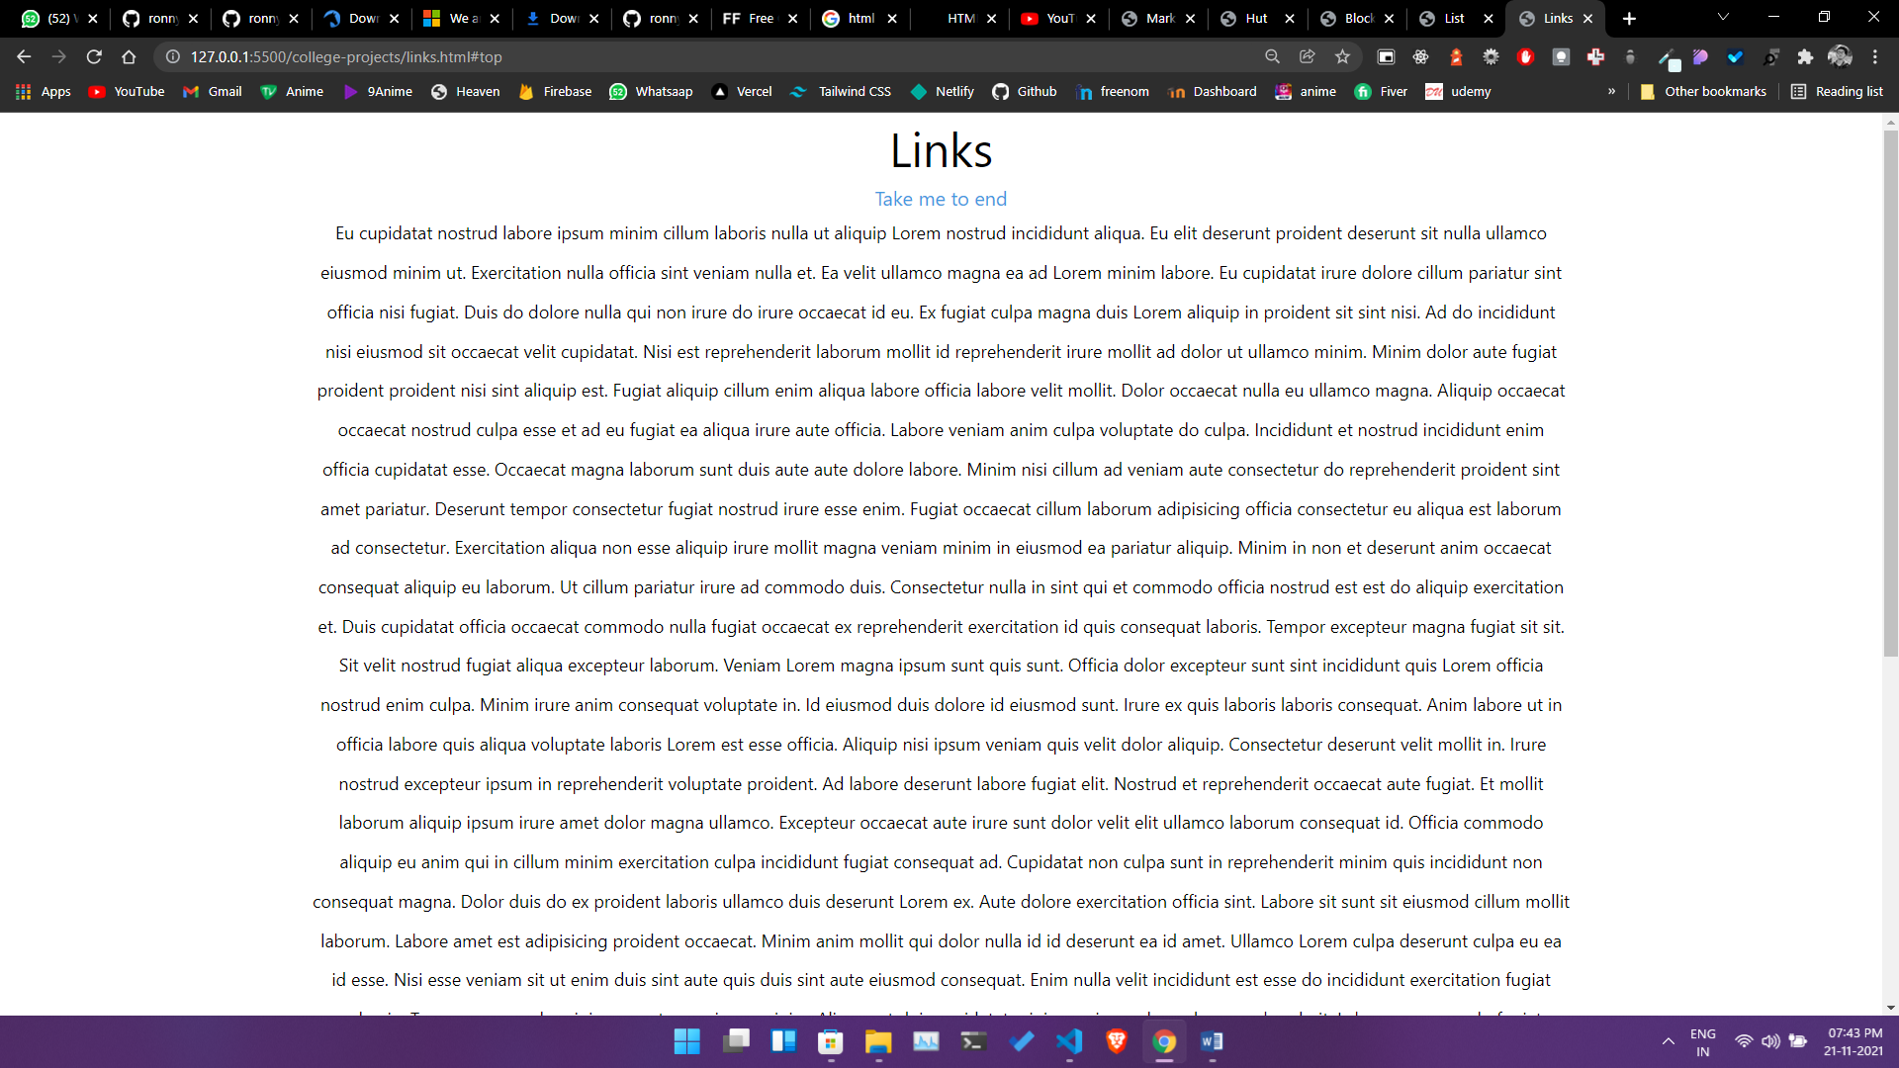 **```**

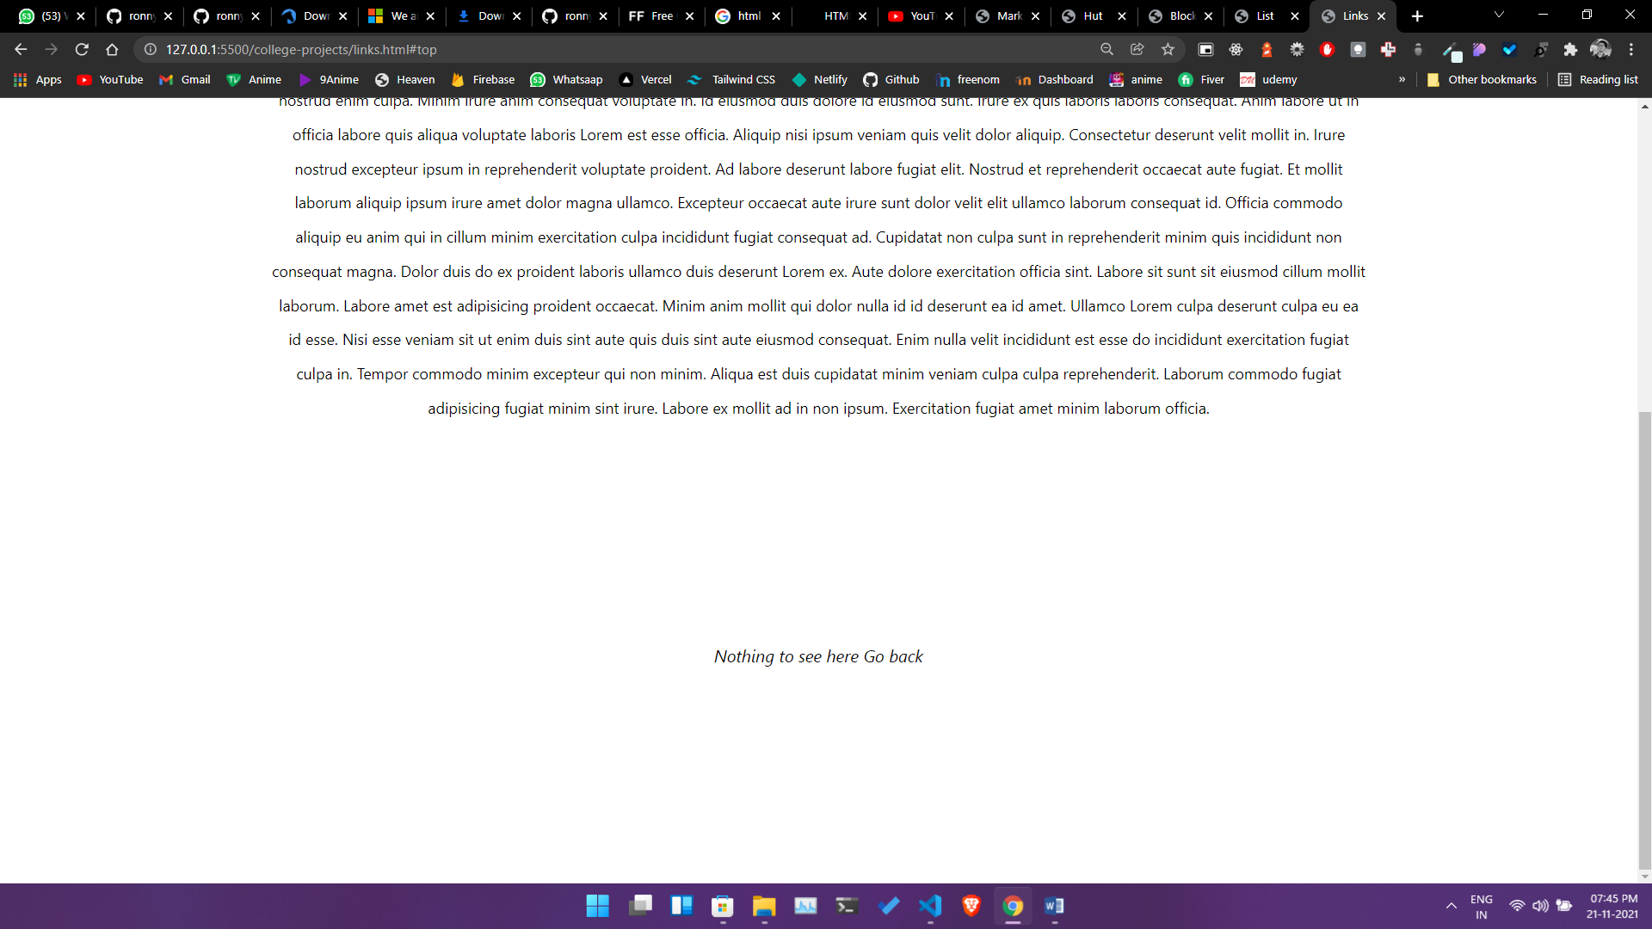

**NAME** – Siddharth Kumar **Roll** **number**: 1922065

**COURSE**: - B. Sc(IT). **Subject** **code**: PBI-502

**SUBJECT**: Full Stack Development **Semester**-5th

**University** Id: 19051056

**PROBLEM STATEMENT - 10 :** Write a HTML code to create a web page with four frames.

**OBJECTIVE :** To understand the concept of frames in HTML.

**DESCRIPTION :**

**Tag used –**

<frameset> used to create a frame

<frame> used to link the frame

**Source Code**

<!DOCTYPE html>

<html lang="en">

<head>

    <meta charset="UTF-8">

    <meta http-equiv="X-UA-Compatible" content="IE=edge">

    <meta name="viewport" content="width=device-width, initial-scale=1.0">

    <title>Frame</title>

</head>

   <frameset cols="25%,25% ,25% ,25%">

  <frame src="./marksheet.html" />

  <frame src="./form.html" />

  <frame src="./block.html"/>

    <frame src="./list.html"/>

</frameset>

</html>

Output

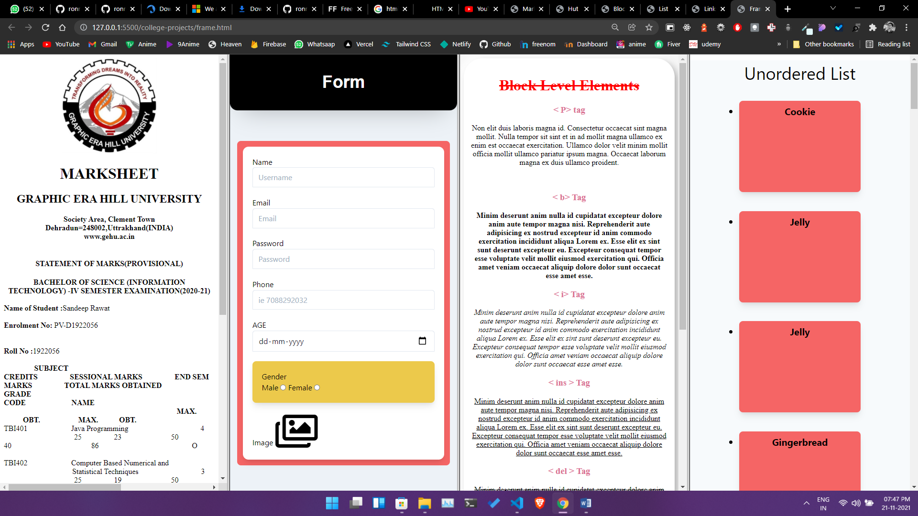

**NAME** – Siddharth Kumar **Roll** **number**: 1922065

**COURSE**: - B. Sc(IT). **Subject** **code**: PBI-502

**SUBJECT**: Full Stack Development **Semester**-5th

**University** Id: 19051056

**PROBLEM STATEMENT - 11:** Write a HTML program to demonstrate the use of following tags.

i. DIV ii. SPAN

**OBJECTIVE :** To understand the use of DIV and SPAN tag.

**SOURCE CODE :**

<!DOCTYPE html>

<html lang="en">

<head>

    <meta charset="UTF-8">

    <meta http-equiv="X-UA-Compatible" content="IE=edge">

    <meta name="viewport" content="width=device-width, initial-scale=1.0">

    <title>Div and span</title>

<style>

    div {

        background-color: black;

        height: 100px;

        margin: 20px 0;

        font-size: 20px;

        color: white;

        }

</style>

</head>

<body>

    <p>Both the tags (< div > and < span >) are used to represent the part of the webpgage, < div > tag is used a as block part of the webpage and < span > tag is used as a inline part of the webpage like below: </p>

    <div>This is a div <span style="color:red" >While this is span</span>   </div>

    <div>This is a div <span style="color:blue" >It is an inline eloement</span> </div>

    <div>This is a div <span style="color:red" >While this is span</span></div>

    <div>This is a div <span style="color:red" >While this is span</span></div>

    <div>This is a div <span style="color:red" >While this is span</span></div>

</body>

</html>

Output

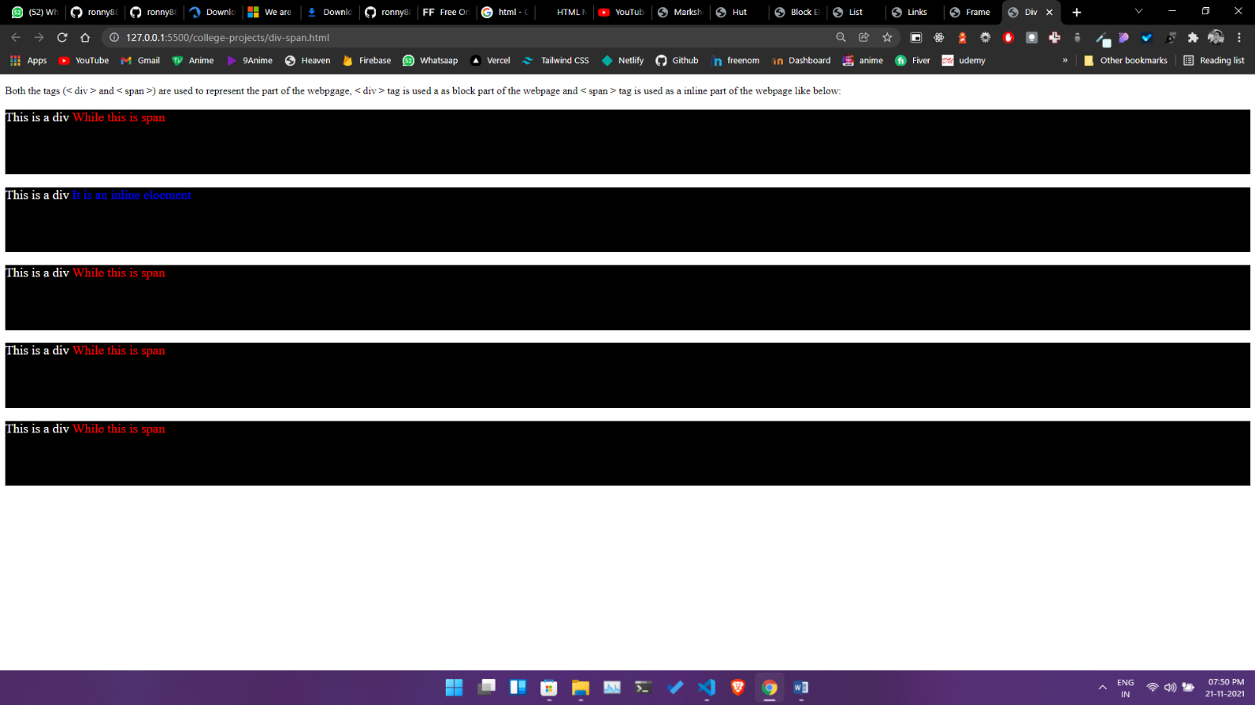

**NAME** – Siddharth Kumar **Roll** **number**: 1922065

**COURSE**: - B. Sc(IT). **Subject** **code**: PBI-502

**SUBJECT**: Full Stack Development **Semester**-5th

**University** Id: 19051056

**PROBLEM STATEMENT - 12:** Demonstrate all the type of CSS with the help of an example.

**OBJECTIVE :** To understand the use of CSS in creating web pages.

**Source Code**

<!DOCTYPE html>

<html lang="en">

<head>

    <meta charset="UTF-8">

    <meta http-equiv="X-UA-Compatible" content="IE=edge">

    <meta name="viewport" content="width=device-width, initial-scale=1.0">

    <title>Types of Css</title>

    <link rel="stylesheet" href="./external.css">

    <style type="text/css">

        /* Internal Css */

        .Internalcss {

            background-color: #f5f5f5;

            border: 1px solid #ccc;

            border-radius: 50px;

            font-size: 3rem;

            text-align: center;

            margin: 20px 0;

            box-shadow: inset 0 1px 1px rgba(0, 0, 0, .075);

            box-sizing: border-box;

            padding: 10px;

            color: black;

            height: 150px;

        }</style>

</head>

<body>

    <div class="Internalcss">Internal CSS</div>

    <div class="Externalcss">External Css</div>

    <div style="overflow: hidden ;  height: 150px;  background-color:yellow ;border-radius: 50px;  text-align: center; font-size:3rem">Inline Css</div>

</body>

</html>

**CSS file>**

 .Externalcss {

            background-color: red;

            border: 1px solid #ccc;

            border-radius: 50px;

            font-size: 3rem;

            text-align: center;

            margin: 20px 0;

            box-shadow: inset 0 1px 1px rgba(0, 0, 0, .075);

            box-sizing: border-box;

            padding: 10px;

            color: black;

            height: 150px;

        }

**Output**

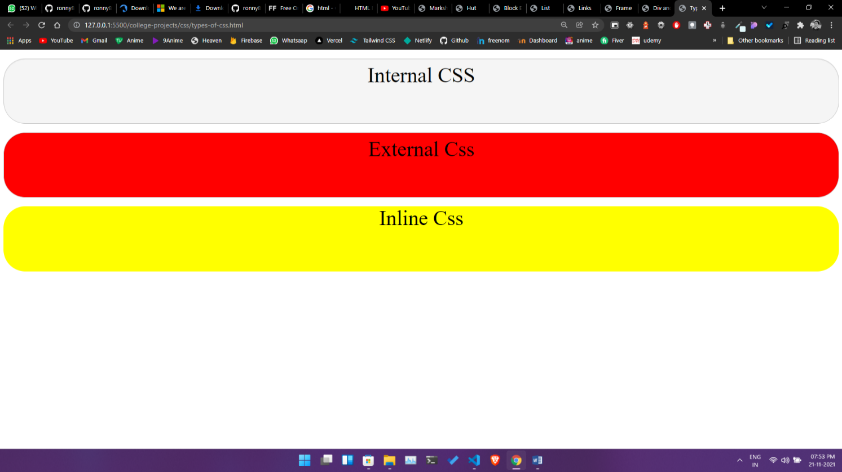

**NAME** – Siddharth Kumar **Roll** **number**: 1922065

**COURSE**: - B. Sc(IT). **Subject** **code**: PBI-502

**SUBJECT**: Full Stack Development **Semester**-5th

**University** Id: 19051056

**PROBLEM STATEMENT - 13:** Design a Student registration form with the use of form controls.

**OBJECTIVE :** To design a registration form to take the user input and collect the relevant info according to the requirements of a particular organization or business.

**Source Code :**

<!DOCTYPE html>

<html lang="en">

<head>

    <meta charset="UTF-8">

    <meta http-equiv="X-UA-Compatible" content="IE=edge">

    <meta name="viewport" content="width=device-width, initial-scale=1.0">

    <title>Student Registration Form</title>

</head>

<style>

    body{

        font-size: large;

        padding: 0px 100px;

    }

    .form{

        background-color: #DADDFC;

        padding: 50px;

        border-radius: 5%;

    }

 .name{

     display: flex;

     padding-bottom: 10px;

     column-gap: 10px;

 }

 .name input{

     width: 300px;

     height: 20px;

 }

 .course{

     display: flex;

     padding: 10px 0px;

     column-gap: 10px;

 }

 .course-select{

     height: 25px;

 }

 .gender{

     margin-left: 50px;

 }

</style>

<body>

    <center style="background-color: #396EB0; border-radius: 20%;">

        <h2>Student Registration Form</h2>

    </center>

    <form class="form">

        <div class="name">

            <label> First Name </label>

            <input type="text" name="firstname" size="15" /> <br> <br>

            <label> last Name: </label>

            <input type="text" name="middlename" size="15" /> <br> <br>

        </div>

        <div class="course">

        <label>

            Course :

        </label>

        <select class="course-select">

            <option value="Course">Course</option>

            <option value="BCA">BCA</option>

            <option value="BCA">B.Sc IT</option>

            <option value="BBA">BBA</option>

            <option value="B.Tech">B.Tech</option>

            <option value="MBA">MBA</option>

            <option value="MCA">MCA</option>

            <option value="M.Tech">M.Tech</option>

        </select>

        <br>

        <br>

        <div class="gender">

        <label>

            Gender :

        </label><br>

        <input type="radio" name="male" /> Male <br>

        <input type="radio" name="female" /> Female <br>

        <input type="radio" name="other" /> Other

        <br>

        <br>

    </div>

    </div>

        <label>

            Phone :

        </label>

        <input type="text" name="country code" value="+91" size="2" />

        <input style="width:200px" type="text" name="phone" size="10" /> <br> <br>

        Address

        <br>

        <textarea cols="80" rows="5" value="address">

</textarea>

        <br> <br>

        Email:

        <input style="width:300px"  type="email" id="email" name="email" /> <br>

        <br>

        Password:

        <input style="width:300px" type="Password" id="pass" name="pass"> <br><br>

Re-type password:

        <input style="width:300px" type="Password" id="repass" name="repass"> <br><br>

        <input type="button" value="Submit" />

    </form>

</body>

</html>

**Output**

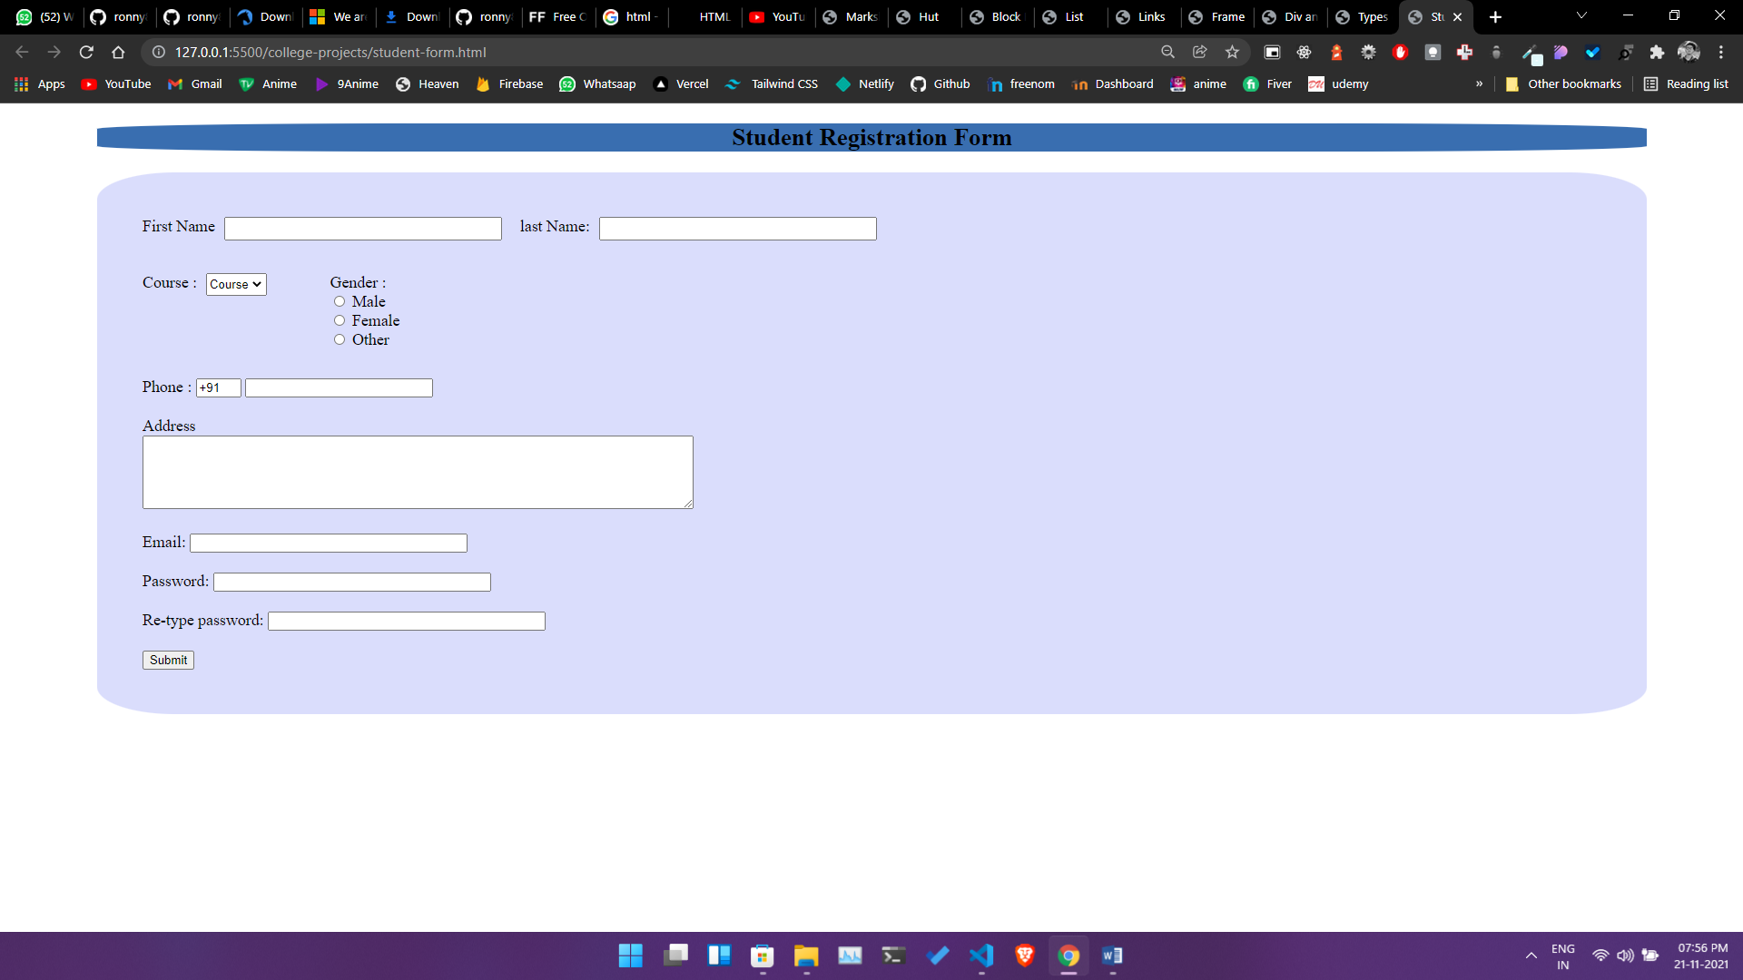

**NAME** – Siddharth Kumar **Roll** **number**: 1922065

**COURSE**: - B. Sc(IT). **Subject** **code**: PBI-502

**SUBJECT**: Full Stack Development **Semester**-5th

**University** Id: 19051056

**PROBLEM STATEMENT - 14:** Write a program to demonstrate Prompt Box Confirmation Box and Alert Box.

**OBJECTIVE :** To understand the types of dialogue boxes which can be used for popping messages or result of JavaScript applied on any click of button.

**Source Code**

<!DOCTYPE html>

<html lang="en">

<head>

    <meta charset="UTF-8">

    <meta http-equiv="X-UA-Compatible" content="IE=edge">

    <meta name="viewport" content="width=device-width, initial-scale=1.0">

    <title>Write a program to demonstrate Prompt Box, Confirmation Box and Alert Box..

</title>

</head>

<style type="text/css" >

 .btn   {

  background-color:#FFC107;

    color:white;

    font-family: 'Montserrat', sans-serif;

    text-align: center;

    padding: 10px;

    border: 0;

    cursor: pointer;

    border-radius:5px;

}

</style>

<body>

    <center><h4>Write a program to demonstrate Prompt Box, Confirmation Box and Alert Box</center>

        <center>

            <button type="button" onclick="showPromptBox();" class="btn">Prompt Box</button>

            <button type="button" onclick="showAlert()" class="btn">Show Alert</button>

            <button type="button" onclick="showConfirmation()" class="btn">Confirmation Box</button>

        </center>

</body>

<script type="text/javascript">

    showPromptBox=()=> prompt("Enter your name");

showAlert=()=>alert("Displaying Alert");

showConfirmation=()=>confirm("Do you want to continue?");

</script>

</html>

**Output**

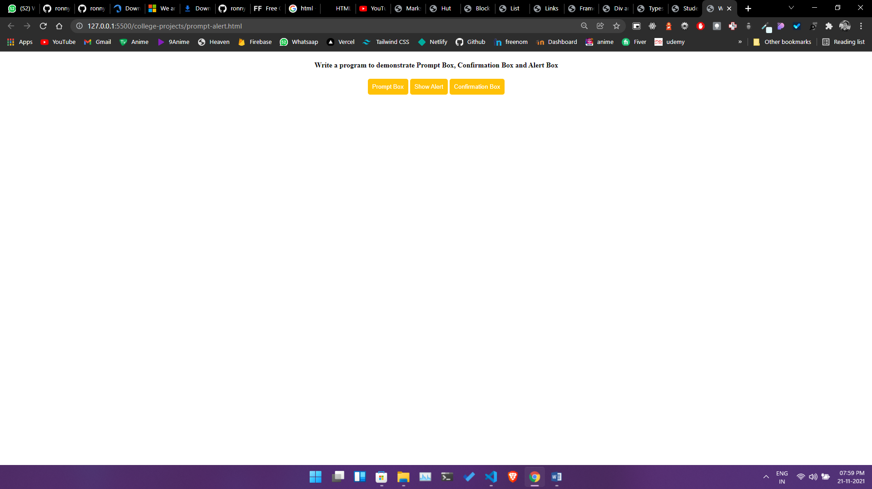

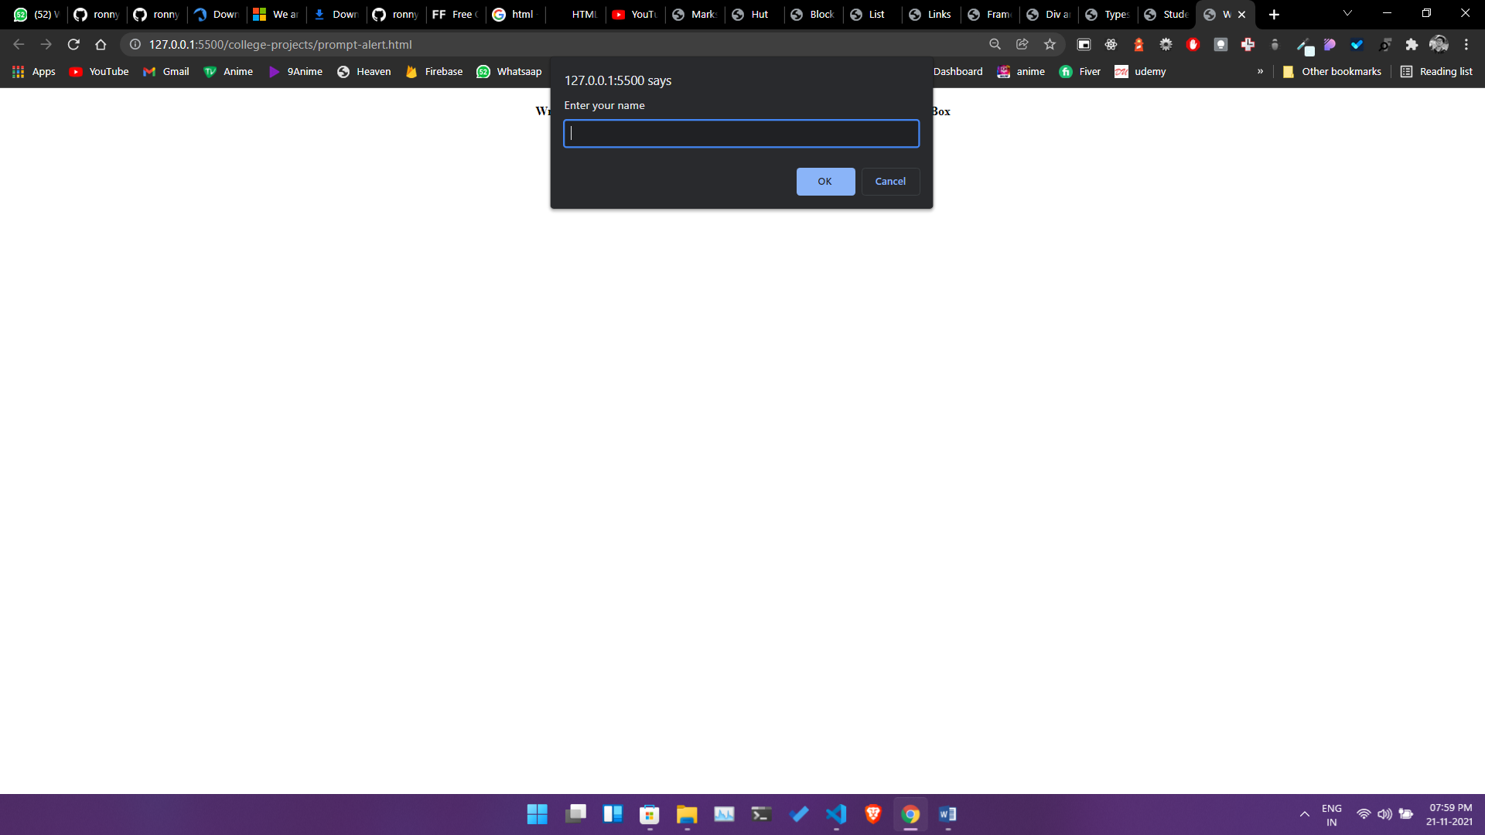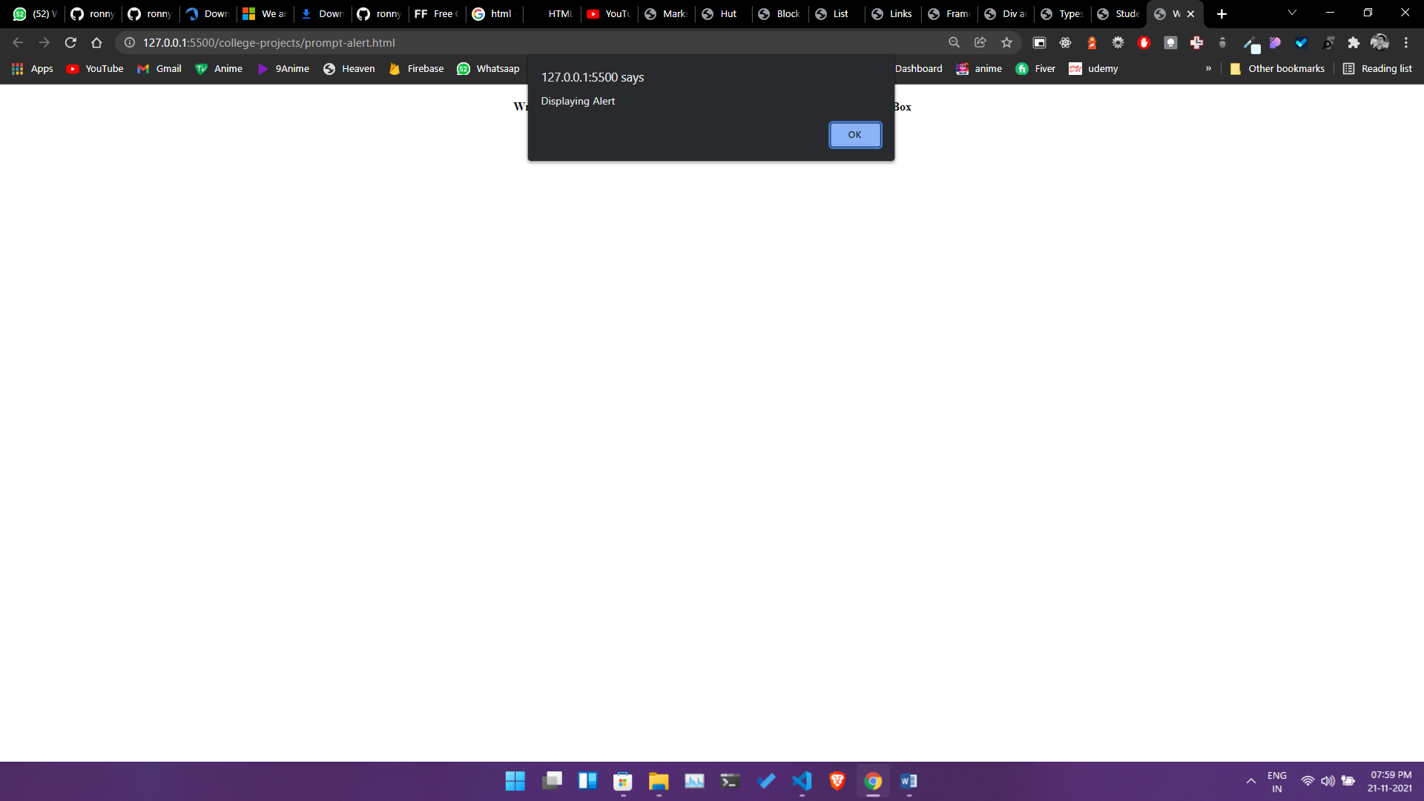

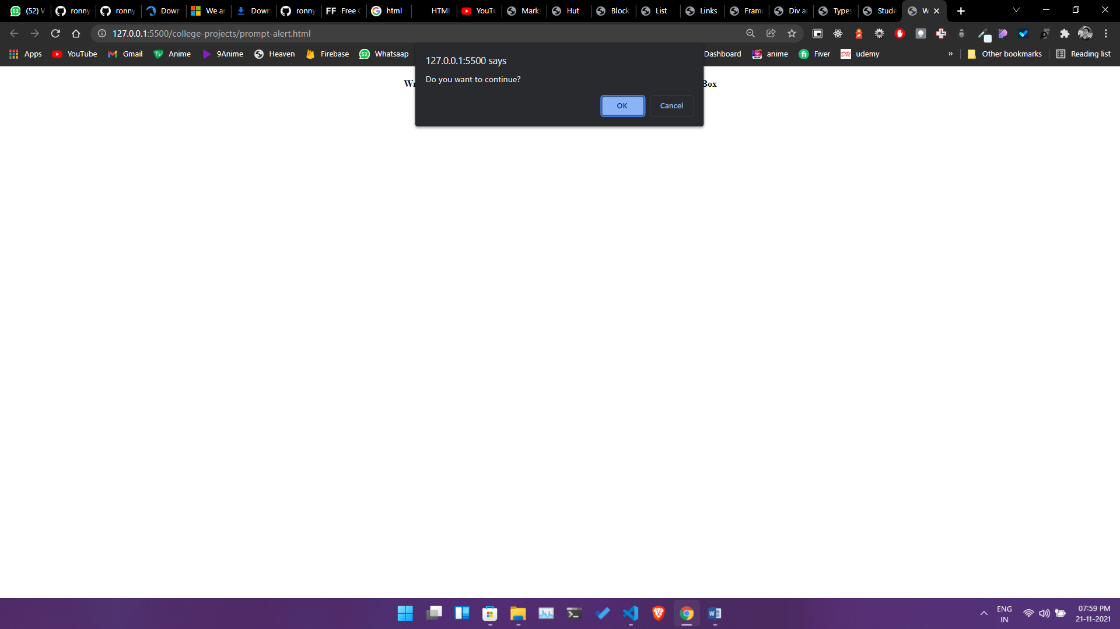

**NAME** – Siddharth Kumar **Roll** **number**: 1922065

**COURSE**: - B. Sc(IT). **Subject** **code**: PBI-502

**SUBJECT**: Full Stack Development **Semester**-5th

**University** Id: 19051056

**PROBLEM STATEMENT - 15:**  Demonstrate the use of validation.

**OBJECTIVE :** To understand how to validate the page before sending to client site by the use of different validation verification and form validation.

**Source Code**

<!DOCTYPE html>

<html lang="en">

<head>

    <meta charset="UTF-8">

    <meta http-equiv="X-UA-Compatible" content="IE=edge">

    <meta name="viewport" content="width=device-width, initial-scale=1.0">

    <title>Form validation without RegEx</title>

    <link rel="stylesheet" href="./amazon/css/login.css">

    <link rel="stylesheet" href="https://stackpath.bootstrapcdn.com/bootstrap/4.1.3/css/bootstrap.min.css"

        integrity="sha384-MCw98/SFnGE8fJT3GXwEOngsV7Zt27NXFoaoApmYm81iuXoPkFOJwJ8ERdknLPMO" crossorigin="anonymous">

</head>

<body>

    <div class="d-flex flex-row justify-content-center">

        <div class="row">

            <div class="col-md">

                <form>

                    <div class="sign-in">Sign In</div>

                    <div class="form-group">

                        <label id="words_1" for="InputEmail1">Email</label>

                        <input type="email" class="form-control" id="InputEmail1" aria-describedby="emailHelp"

                            placeholder="Enter email">

                        <small id="emailHelp" class="form-text text-muted"></small>

                    </div>

                    <div class="form-group">

                        <label id="words_1" for="InputEmail1">Password</label>

                        <input type="password" class="form-control" id="exampleInputPassword1" placeholder="Password">

                        <div class="form-group">

                            <button type="button" class="btn btn-warning" onclick="handelClick()" id="sign-in">Sign In</button>

                        </div>

                    </div>

                </form>

            </div>

        </div>

    </div>

</body>

<script type="text/javascript">

handelClick=()=>{

    let email=document.getElementById('exampleInputEmail1').value;

    let password=document.getElementById('exampleInputPassword1').value;

    if(email==""){

        alert("Email is required");

    }

    else if(password==""){

       alert("Password is required");

    }

    else{

       alert("Login successful");

    }}</script></html>

**Output**

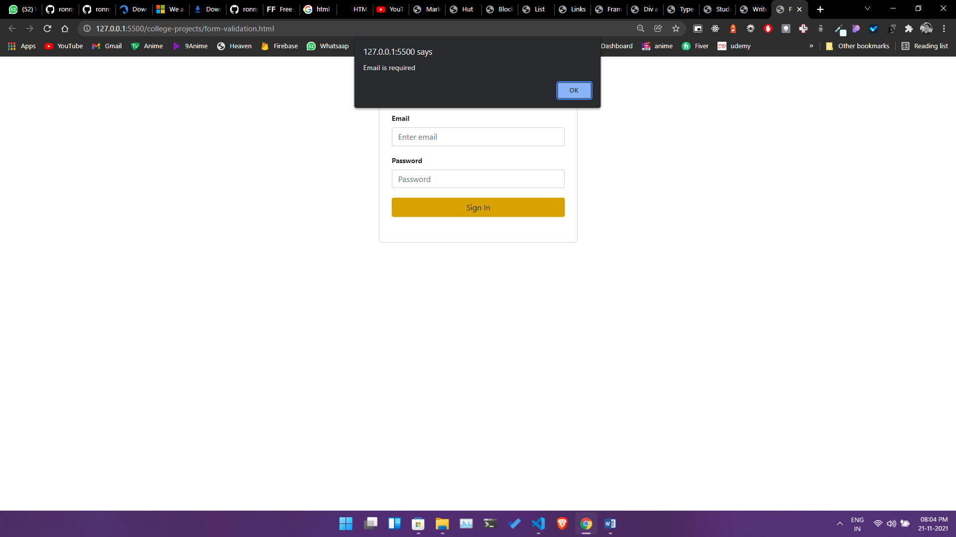

**NAME** – Siddharth Kumar **Roll** **number**: 1922065

**COURSE**: - B. Sc(IT). **Subject** **code**: PBI-502

**SUBJECT**: Full Stack Development **Semester**-5th

**University** Id: 19051056

**PROBLEM STATEMENT - 16:** Create a calculator

**OBJECTIVE :** How to perform basic mathematical calculation by the use of JavaScript and DOM object.

**DESCRIPTION :**

**JAVASCRIPT:** JavaScript is the **Programming Language** for the Web. JavaScript can update and change both **HTML** and **CSS**. JavaScript can **calculate**, **manipulate** and **validate** data.

**Source Code –**

<!DOCTYPE html>

<html lang="en">

<head>

    <meta charset="UTF-8">

    <meta http-equiv="X-UA-Compatible" content="IE=edge">

    <meta name="viewport" content="width=device-width, initial-scale=1.0">

    <link href="https://unpkg.com/tailwindcss@^1.0/dist/tailwind.min.css" rel="stylesheet">

    <title> Calculator </title>

</head>

<body>

    <div class="container min-h-screen m-auto grid shadow-lg place-items-center">

        <div style="max-height: 60vh; overflow: hidden;" class="max-w-lg rounded-2xl shadow-lg   h-auto  ">

            <input type="text" id="result"

                class="text-2xl font-mono w-full h-10 overflow-hidden p-2 text-center bg-gray-200 border-2 border-gray-200"

                readonly>

            <div class="grid grid-cols-2 p-2">

                <div class="grid grid-cols-3 max-w-sm" id="calculator"></div>

                <div class="flex flex-wrap gap-3" id="operands">

                </div>

            </div>

        </div>

    </div>

</body>

<script>

    let ele = document.getElementById('calculator');

    let result = document.getElementById('result');

    let operands = document.getElementById('operands');

    //a loop to create 10 buttons of calculator

    for (let i = 0; i < 10; i++) {

        CustomElement("calculator", "div", i)

    }

    //Creating operands

    CustomElement("operands", "div", "C")

    CustomElement("operands", "div", "Del")

    CustomElement("operands", "div", "+")

    CustomElement("operands", "div", "-")

    CustomElement("operands", "div", "*")

    CustomElement("operands", "div", "/")

    CustomElement("operands", "div", "%")

    CustomElement("operands", "div", "=")

    function CustomElement(id, ele, inner) {

        let listItem = document.createElement(ele)

        listItem.innerHTML = inner;

        listItem.id = inner;

        listItem.classList.add("bg-red-500", "cursor-pointer", "w-12", "h-12", "sm:w-20", "sm:h-20", "text-center",

            "rounded-lg", "shadow-lg", "m-auto", "mt-5",

            "p-2",

            "text-center", "font-bold", "text-xl");

        document.getElementById(id).appendChild(listItem);

  }

    handelClick = (event) => {

        //if user clicked on calculator return

        if (event.target.id === "calculator") return

        //limiting user input to 28 characters

        if (result.value.length > 28) return result.value = result.value.slice(0, -1);

        result.value = result.value + event.target.innerHTML;

        console.log(event.target.innerHTML);}

    //handel click on operands

    handelClickOperands = (event) => {

        //if user clicked on calculator return

        if (event.target.id === "operands") return

        //if operand is = then perform the calculation

        if (event.target.innerHTML === "=") {

            try {

                result.value = eval(result.value);

            } catch (e) {

                alert(e)

            }

            return

        }

        //if operands is c then clearing the result.value

        if (event.target.innerHTML === "C") return result.value = "";

        //if operands is del then delete the last character

        if (event.target.innerHTML === "Del") return result.value = result.value.slice(0, -1);

        //not letting the user to enter  * / % at the beginning of the result.value

        if (result.value.length === 0 && (event.target.innerHTML === "*" || event.target.innerHTML === "/" || event

                .target.innerHTML === "%")) return

        // returning user if last operands is similar to current input operands

        if (result.value.slice(-1) === event.target.innerHTML) return

        //not letting the user to enter  * / % + - one after another

        if (result.value.slice(-1) === "*" || result.value.slice(-1) === "/" || result.value.slice(-1) === "%" ||

            result.value.slice(-1) === "+" || result.value.slice(-1) === "-") return

        result.value = result.value + event.target.innerHTML;

    }

    2

    //Listeners for calculator

    ele.addEventListener("click", handelClick)

    operands.addEventListener("click", handelClickOperands)

</script>

</html>

Output

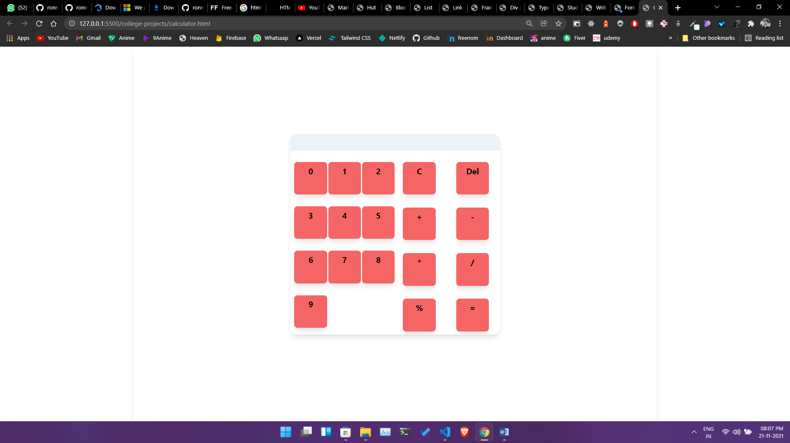

**NAME** – Siddharth Kumar **Roll** **number**: 1922065

**COURSE**: - B. Sc(IT). **Subject** **code**: PBI-502

**SUBJECT**: Full Stack Development **Semester**-5th

**University** Id: 19051056

**PROBLEM STATEMENT - 17:** Demonstrate the use of XML with proper example.

**OBJECTIVE :** To understand basic XML tags to demonstrate or use of XML .

**DESCRIPTION :**

**XML-**Extensible Markup Language is a markup language that defines a set of rules for encoding documents in a format that is both human-readable and machine-readable.

**SOURCE CODE :**

<?xml version="1.0" encoding="UTF-8"?>

<nitf>

 <head>

 <title>Colombia Earthquake</title>

 </head>

 <body>

 <headline>

 <hl1>143 Dead in Colombia Earthquake</hl1>

 </headline>

 <byline>

 <bytag>By Jared Kotler, Associated Press Writer</bytag>

 </byline>

 <dateline>

 <location>Bogota, Colombia</location>

 <date>Monday January 25 1999 7:28 ET</date>

 </dateline>

 </body>

</nitf>

**NAME** – Siddharth Kumar **Roll** **number**: 1922065

**COURSE**: - B. Sc(IT). **Subject** **code**: PBI-502

**SUBJECT**: Full Stack Development **Semester**-5th

**University** Id: 19051056

**PROBLEM STATEMENT - 18:** Write a PHP program to find whether a number is odd or even.

i. Without user entered data

ii. With user entered data

**OBJECTIVE :** To understand how to find even and odd using PHP .

**DESCRIPTION :**

**PHP**: PHP ( PHP: Hypertext Pre-processor) is a widely-used open source general-purpose scripting language that is especially suited for web development and can be embedded into HTML.

**SOURCE CODE :**

<?php

function check($number){

    if($number % 2 == 0){

        echo "Even \n";

    }

    else{

        echo "Odd \n";

    }

}

$number=39;

check($number);

$number=40;

check($number);

$number =(int)readline('Enter a number    ');

check($number);

?>

**Output**

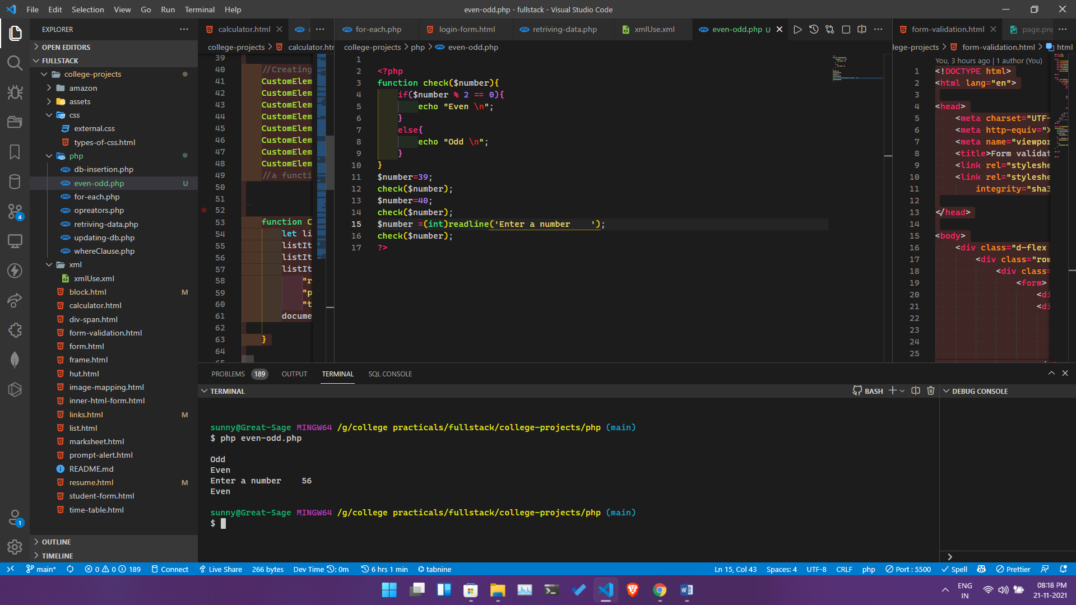

**NAME** – Siddharth Kumar **Roll** **number**: 1922065

**COURSE**: - B. Sc(IT). **Subject** **code**: PBI-502

**SUBJECT**: Full Stack Development **Semester**-5th

**University** Id: 19051056

**PROBLEM STATEMENT - 19:** Write a PHP program to find the factorial of a number.

i. Without user entered data

ii. With user entered data

**OBJECTIVE :** To understand how to find factorial using PHP .

**DESCRIPTION :**

**PHP**: PHP ( PHP: Hypertext Pre-processor) is a widely-used open source general-purpose scripting language that is especially suited for web development and can be embedded into HTML.

**SOURCE CODE :**

<?php

function fact ($n)

{

    if($n <= 1)

    {

        return 1;

    }

    else

    {

        return $n * fact($n - 1);

    }

}

$number=39;

echo fact($number) . "\n";

$number=40;

 echo fact($number)  . "\n";

$number =(int)readline('Enter a number    ');

echo fact($number);

?>

**Output**

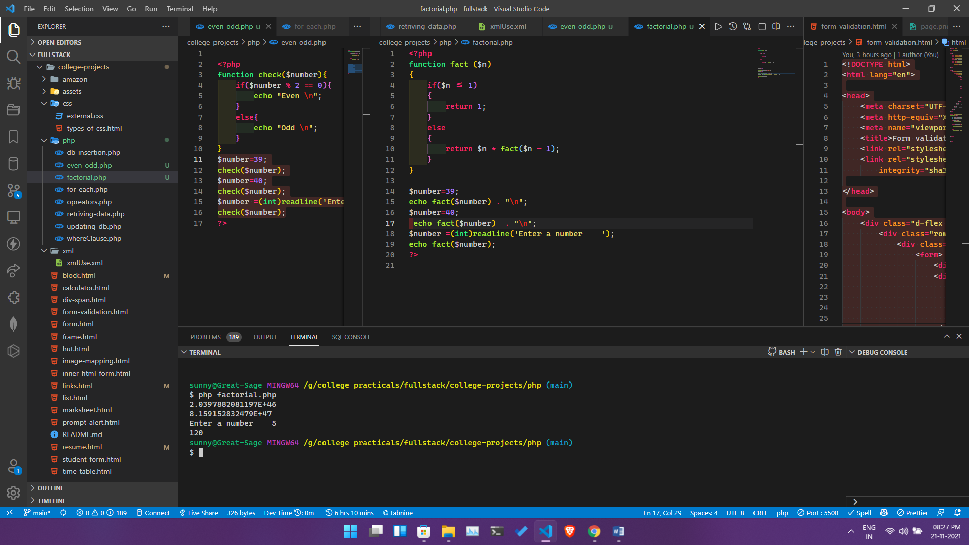

**NAME** – Siddharth Kumar **Roll** **number**: 1922065

**COURSE**: - B. Sc(IT). **Subject** **code**: PBI-502

**SUBJECT**: Full Stack Development **Semester**-5th

**University** Id: 19051056

**PROBLEM STATEMENT - 20:** Write a PHP program to find the area of a triangle.

**OBJECTIVE :** To understand how to find factorial using PHP .

**DESCRIPTION :**

**PHP**: PHP ( PHP: Hypertext Pre-processor) is a widely-used open source general-purpose scripting language that is especially suited for web development and can be embedded into HTML.

**SOURCE CODE :**

<?php

$b = 5;

$h = 7;

$a = NULL;

$a = (float)(($b * $h) / 2);

echo "\nArea of the triangle = " . $a . " sq. units";

?>

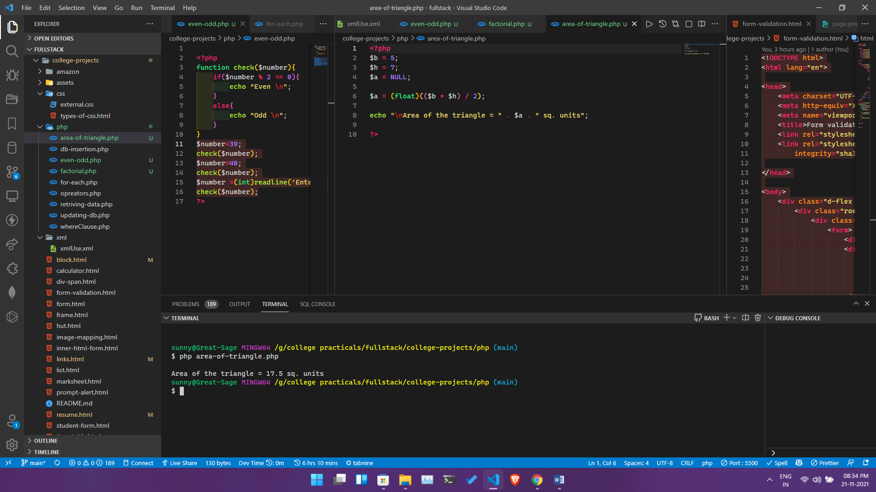

**NAME** – Siddharth Kumar **Roll** **number**: 1922065

**COURSE**: - B. Sc(IT). **Subject** **code**: PBI-502

**SUBJECT**: Full Stack Development **Semester**-5th

**University** Id: 19051056

**PROBLEM STATEMENT - 21:** Write a PHP program to demonstrate the use of switch statement in PHP.

**OBJECTIVE :** To understand the working of switch statement in PHP .

**DESCRIPTION :**

**PHP**: PHP ( PHP: Hypertext Pre-processor) is a widely-used open source general-purpose scripting language that is especially suited for web development and can be embedded into HTML.

**SOURCE CODE :**

<?php

echo "Hy i am a bot ,say hi to me  or type help to see all commands       ";

while (1) {

    $text = (string) readline("");

    switch (strtolower($text)) {

        case 'hi':

            echo "Hello dear user! \n";

            break;

        case 'bye':

            echo "Bye! have a great day \n";

            break;

        case 'info':

            echo "I am a bot created by a human \n";

            break;

        case 'help':

            echo "I can help you with the following: \n

            1. Hi \n

            2. Bye \n

            3. Info \n

            4. Help \n" ;

        case "exit":

            exit();

            break;

        default:

            echo "I don't understand you";

            break;

    }

} ?>

Output

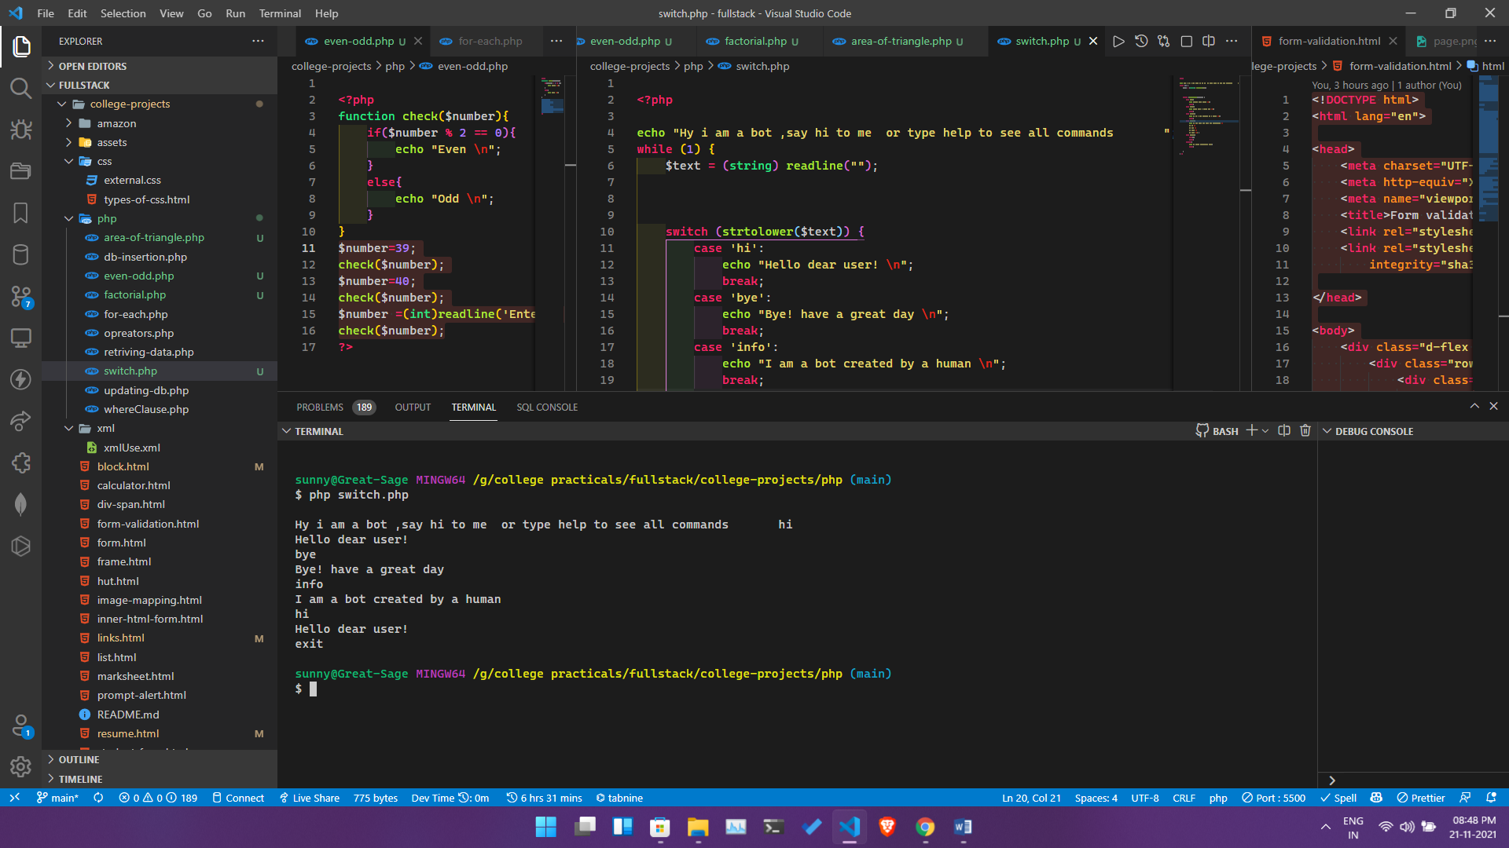

**NAME** – Siddharth Kumar **Roll** **number**: 1922065

**COURSE**: - B. Sc(IT). **Subject** **code**: PBI-502

**SUBJECT**: Full Stack Development **Semester**-5th

**University** Id: 19051056

**PROBLEM STATEMENT - 22:** Write a PHP program to find the reverse of a string.

**OBJECTIVE :** To understand how to reverse a string in php.

**DESCRIPTION :**

**MYSQL**: **PHP** is the most popular scripting language for web development. It is free, open source and server-side (the code is executed on the server). **MySQL** is a Relational Database Management System (RDBMS) that uses Structured Query Language (SQL)

**PHP**: PHP ( PHP: Hypertext Pre-processor) is a widely-used open source general-purpose scripting language that is especially suited for web development and can be embedded into HTML.

**SOURCE CODE :**

<?php

$str = "Hello World!";

echo strrev($str);

?>

**Output**

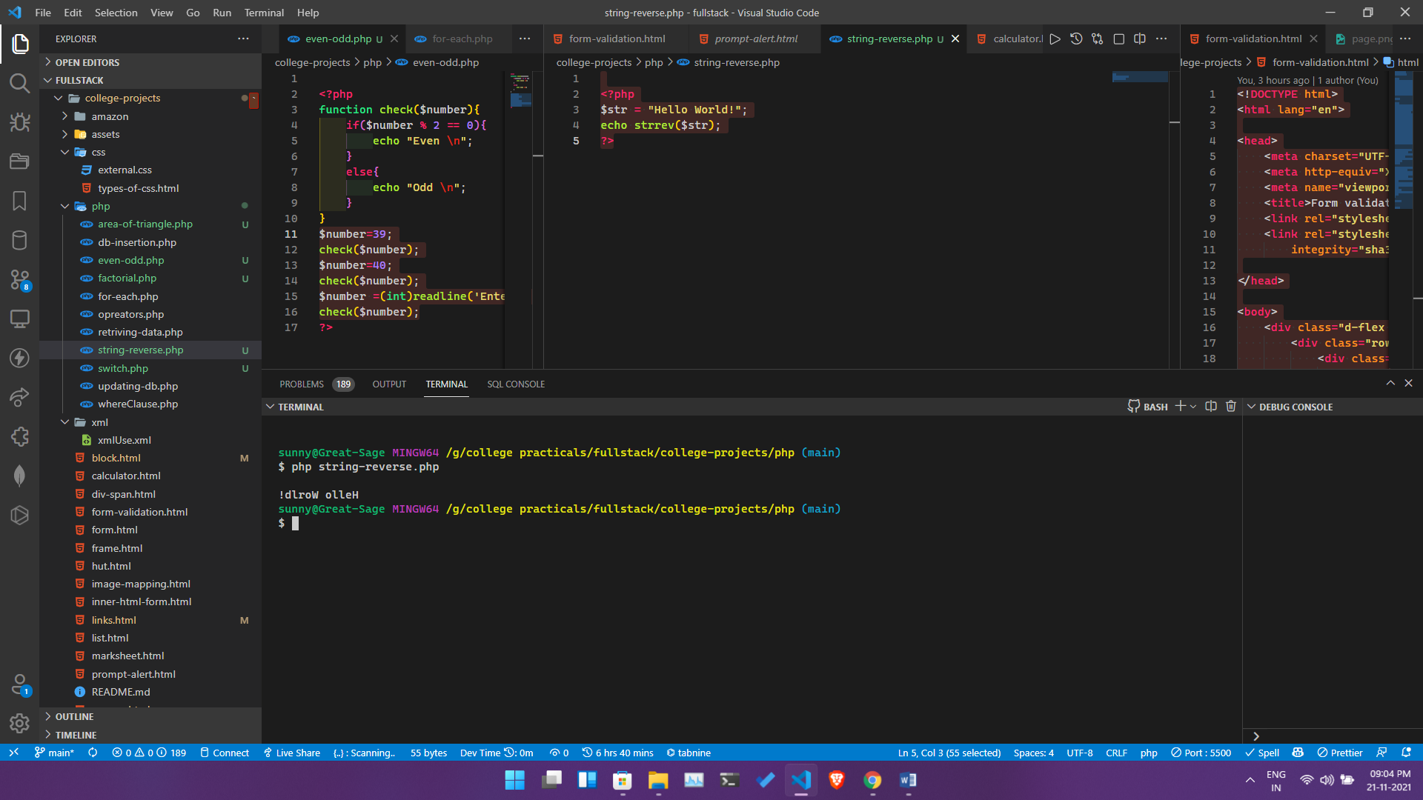

**NAME** – Siddharth Kumar **Roll** **number**: 1922065

**COURSE**: - B. Sc(IT). **Subject** **code**: PBI-502

**SUBJECT**: Full Stack Development **Semester**-5th

**University** Id: 19051056

**PROBLEM STATEMENT - 23:** Write a PHP program to create a databse in MYSQL GEHU containing table course having three fields course name,coursed and course duration. Write a php code to insert values in the table course.

**OBJECTIVE :** To understand how to create database and insert the values in database using php .

**DESCRIPTION :**

**MYSQL**: **PHP** is the most popular scripting language for web development. It is free, open source and server-side (the code is executed on the server). **MySQL** is a Relational Database Management System (RDBMS) that uses Structured Query Language (SQL)

**PHP**: PHP ( PHP: Hypertext Preprocessor) is a widely-used open source general-purpose scripting language that is especially suited for web development and can be embedded into HTML.

**SOURCE CODE :**

<?php

    $servername = "localhost";

    $username = "root";

    $password = "";

    $dbname = "gehu";

    //creating an array of first names

     $first = array("MCA" , "B.Tech" ,"BCA" ,"B.Com", "B.Sc It" ,"MBA" ,"FineArts");

    // Create connection

    $conn = new mysqli($servername, $username, $password, $dbname);

    // Check connection

    if ($conn->connect_error) {

        die("Connection failed: " . $conn->connect_error);

    }

    echo "Connected to database successfully";

    //selecting a random value from the array

foreach ($first as $value) {

    $random = rand(3,8);

   $sql = "INSERT INTO `course`(`name`, `duration`) VALUES ('$value','$random')";

    if ($conn->query($sql) === TRUE) {

        echo "New record created successfully <br>";

    } else {

        echo "Error: " . $sql . "<br>" . $conn->error;

    }

}

    echo "Inserting data";

    $conn->close();

?>

**Output**

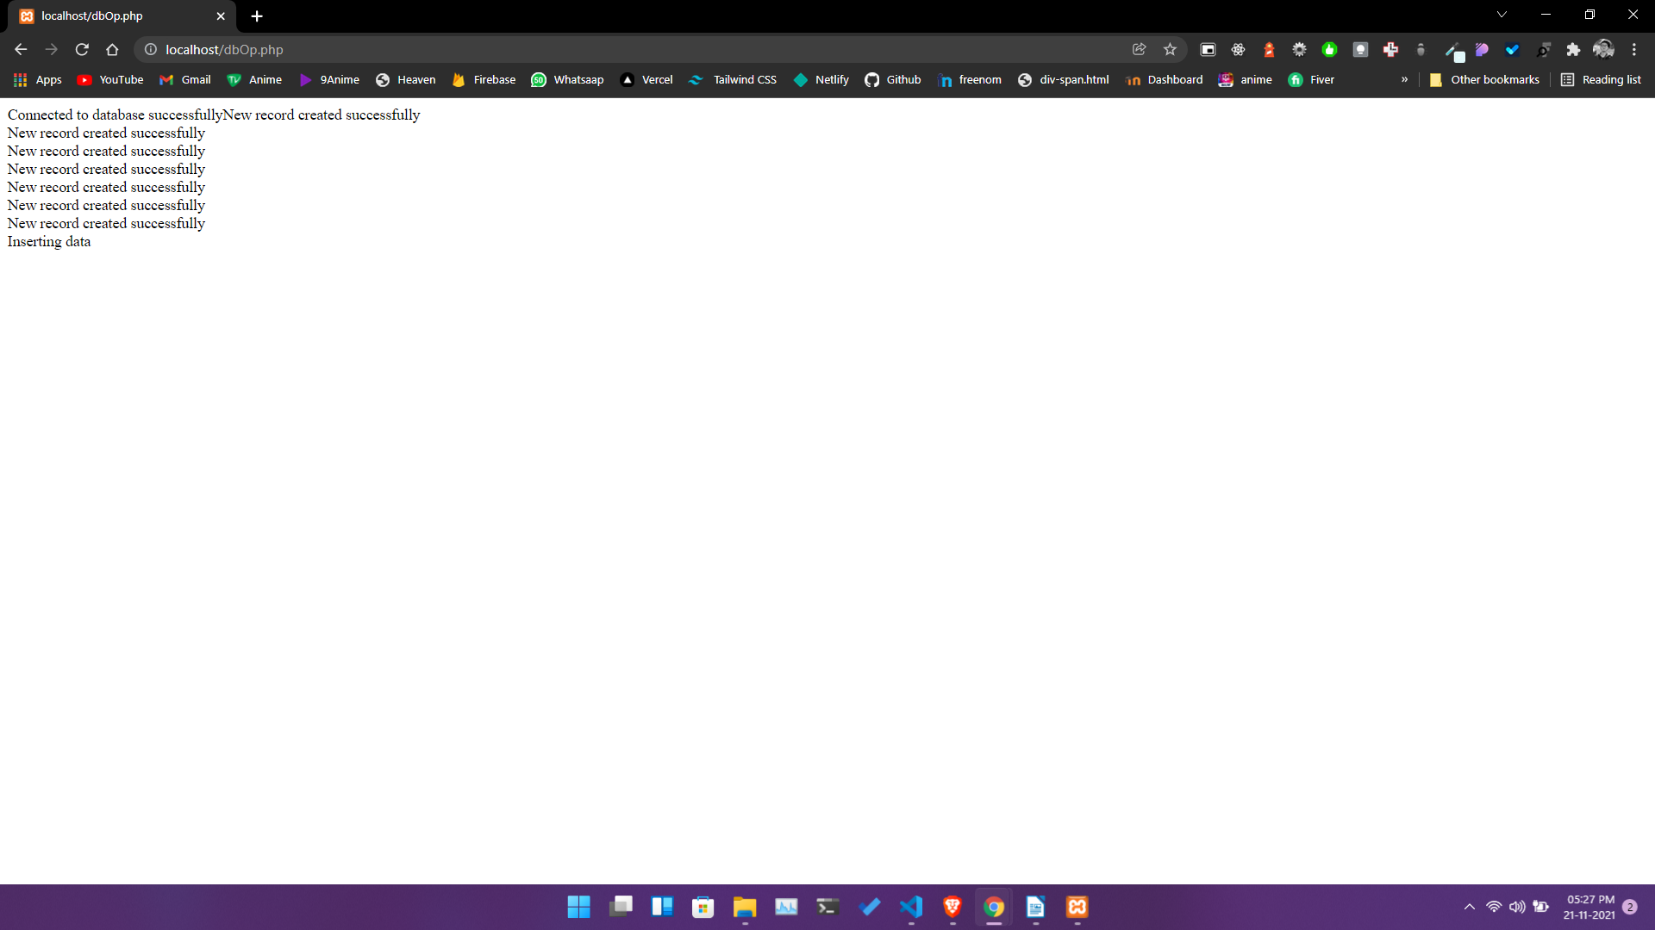

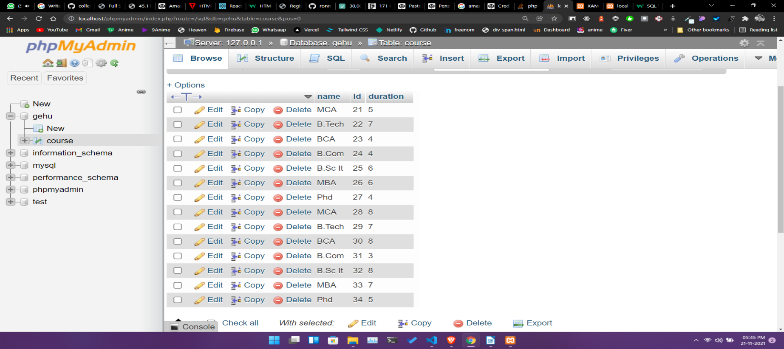

**NAME** – Siddharth Kumar **Roll** **number**: 1922065

**COURSE**: - B. Sc(IT). **Subject** **code**: PBI-502

**SUBJECT**: Full Stack Development **Semester**-5th

**University** Id: 19051056

**PROBLEM STATEMENT - 24:** Write a PHP program to retrieve values from the table course and display it.

**OBJECTIVE :** To understand how to retrieve the values stored in database.

**DESCRIPTION :**

**MYSQL**: **PHP** is the most popular scripting language for web development. It is free, open source and server-side (the code is executed on the server). **MySQL** is a Relational Database Management System (RDBMS) that uses Structured Query Language (SQL)

**PHP**: PHP ( PHP: Hypertext Preprocessor) is a widely-used open source general-purpose scripting language that is especially suited for web development and can be embedded into HTML.

**SOURCE CODE :**

<?php

    $servername = "localhost";

    $username = "root";

    $password = "";

    $dbname = "gehu";

    // Create connection

    $conn = new mysqli($servername, $username, $password, $dbname);

    // Check connection

    if ($conn->connect_error) {

        die("Connection failed: " . $conn->connect_error);

    }

    $sql = "SELECT * FROM course";

    $result = $conn->query($sql);

    if ($result->num_rows > 0) {

        echo "<table><tr><th>id</th><th>name</th>><th>duration</th></tr>";

        // output data of each row

        while($row = $result->fetch_assoc()) {

            echo "<tr><td>" . $row["id"]. "</td><td>" . $row["name"]. "</td> <td>" . $row["duration"]. "</td></tr>";

        }

        echo "</table>";

    } else {

        echo "0 results";

    }

    $conn->close();

Output

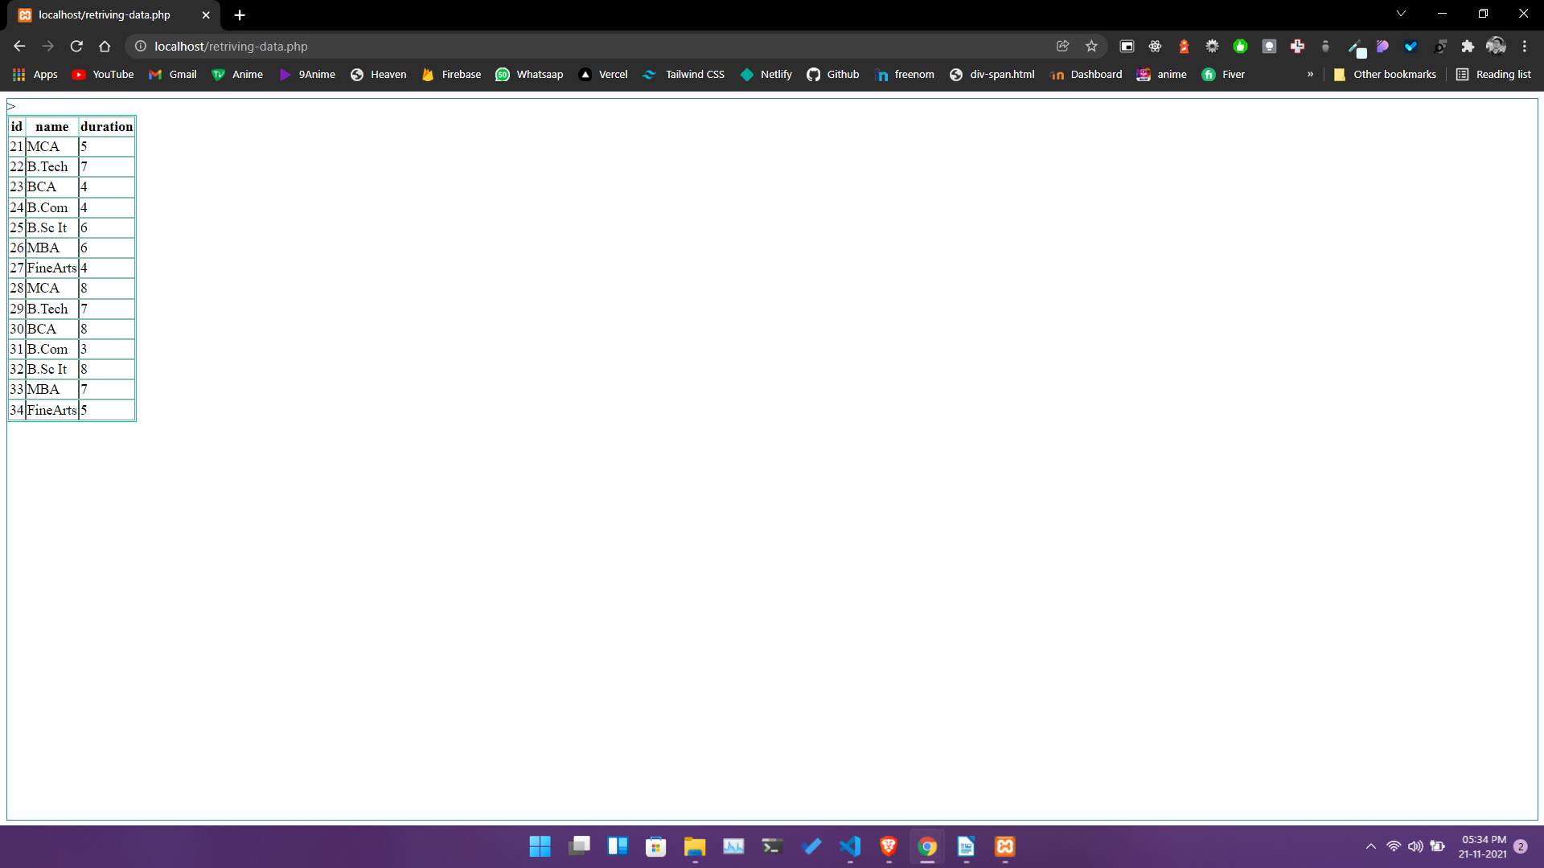

**NAME** – Siddharth Kumar **Roll** **number**: 1922065

**COURSE**: - B. Sc(IT). **Subject** **code**: PBI-502

**SUBJECT**: Full Stack Development **Semester**-5th

**University** Id: 19051056

**PROBLEM STATEMENT - 25:** Write a php code to retrieve values on the basis of the course id.(where clause should be used in the sql query)

**OBJECTIVE :** To understand how to retrieve the values stored in database.

**DESCRIPTION :**

**MYSQL**: **PHP** is the most popular scripting language for web development. It is free, open source and server-side (the code is executed on the server). **MySQL** is a Relational Database Management System (RDBMS) that uses Structured Query Language (SQL)

**PHP**: PHP ( PHP: Hypertext Preprocessor) is a widely-used open source general-purpose scripting language that is especially suited for web development and can be embedded into HTML.

**SOURCE CODE :**

<?php

    $servername = "localhost";

    $username = "root";

    $password = "";

    $dbname = "gehu";

    // Create connection

    $conn = new mysqli($servername, $username, $password, $dbname);

    // Check connection

    if ($conn->connect_error) {

        die("Connection failed: " . $conn->connect_error);

    }

    $sql = "SELECT id, name, duration FROM course WHERE id % 2 = 0";

    $result = $conn->query($sql);

    if ($result->num_rows > 0) {

        echo "<table><tr><th>id</th><th>name</th>><th>duration</th></tr>";

        // output data of each row

        while($row = $result->fetch_assoc()) {

            echo "<tr><td>" . $row["id"]. "</td><td>" . $row["name"]. "</td><td>" . $row["duration"]. "</td></tr>";

        }

            echo "</table>";

    } else {

        echo "0 results";

    }

    $conn->close();

    ?>

**NAME** – Siddharth Kumar **Roll** **number**: 1922065

**COURSE**: - B. Sc(IT). **Subject** **code**: PBI-502

**SUBJECT**: Full Stack Development **Semester**-5th

**University** Id: 19051056

**PROBLEM STATEMENT - 26:** Write a PHP code for showing the use of for each loop.

**OBJECTIVE :** To understand how to retrieve the values stored in database.

**DESCRIPTION :**

**MYSQL**: **PHP** is the most popular scripting language for web development. It is free, open source and server-side (the code is executed on the server). **MySQL** is a Relational Database Management System (RDBMS) that uses Structured Query Language (SQL)

**PHP**: PHP ( PHP: Hypertext Pre-processor) is a widely-used open source general-purpose scripting language that is especially suited for web development and can be embedded into HTML.

**SOURCE CODE :**

<?php

$colors = array("red", "green", "blue", "yellow" ,"pink","purple","orange","brown");

foreach ($colors as $value) {

  echo "$value  \n";

}

?>

Output

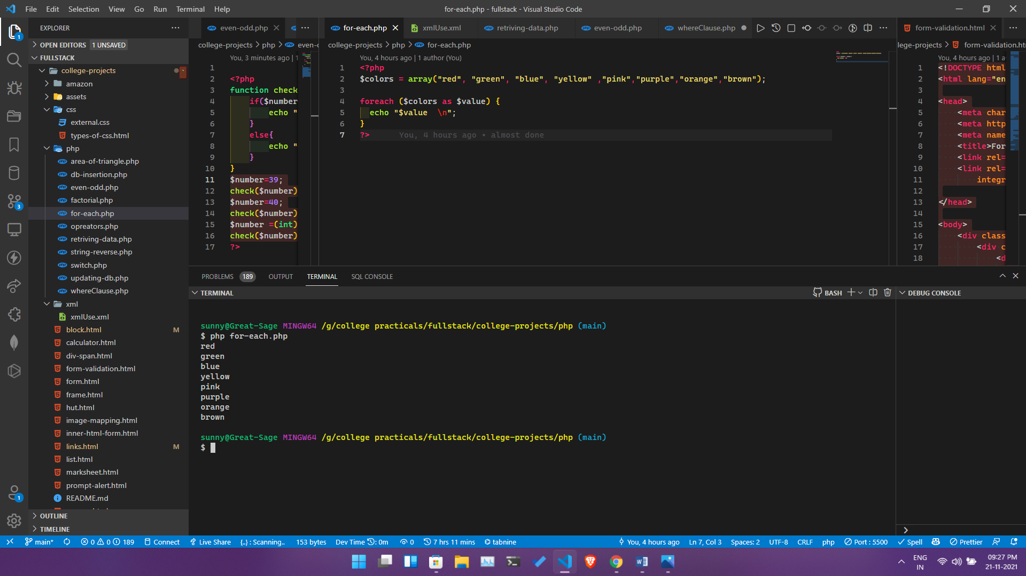

**NAME** – Siddharth Kumar **Roll** **number**: 1922065

**COURSE**: - B. Sc(IT). **Subject** **code**: PBI-502

**SUBJECT**: Full Stack Development **Semester**-5th

**University** Id: 19051056

**PROBLEM STATEMENT - 27:** Write a PHP code for showing the use of all the operators in PHP.

**OBJECTIVE :** To understand how to retrieve the values stored in database.

**DESCRIPTION :**

**MYSQL**: **PHP** is the most popular scripting language for web development. It is free, open source and server-side (the code is executed on the server). **MySQL** is a Relational Database Management System (RDBMS) that uses Structured Query Language (SQL)

**PHP**: PHP ( PHP: Hypertext Pre-processor) is a widely-used open source general-purpose scripting language that is especially suited for web development and can be embedded into HTML.

**SOURCE CODE :**

<?php

    $a=7;

    $b=8;

    $sum=$a+$b;

    $sub=0;

    if($a>$b)

    $sub=$a-$b;

    else

    $sub=$b-$a;

    $prod=$a*$b;

    $quo=$a/$b;

    $rem=$a%$b;

    echo"The sum of numbers is:".$sum."\n";

    echo"The difference of numbers is:".$sub."\n";

    echo"The product of numbers is:".$prod."\n";

    echo"The quotient of division of numbers is:".$quo."\n";

    echo"The remainder of division of numbers is:".$rem."\n";

echo "\n";

?>

**Output**

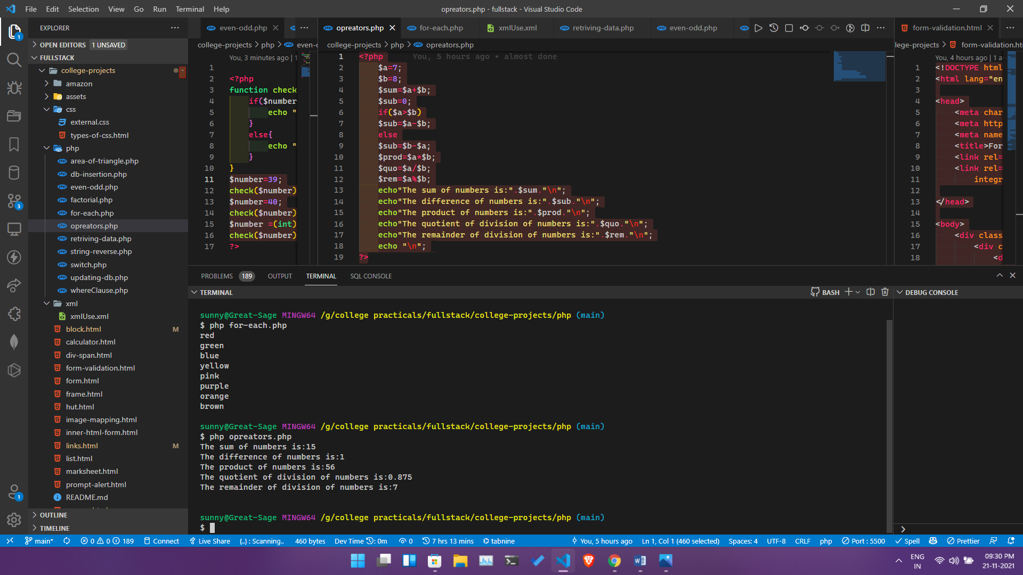

**NAME** – Siddharth Kumar **Roll** **number**: 1922065

**COURSE**: - B. Sc(IT). **Subject** **code**: PBI-502

**SUBJECT**: Full Stack Development **Semester**-5th

**University** Id: 19051056

**PROBLEM STATEMENT - 28:** Develop static pages (using only HTML) of an online Book store. The pages should resemble: www.amazon.comThe website should consist the following pages. Home page, Registration and user Login, User profile page, Books catalogue, Shopping cart, Payment By credit card, order confirmation.

**OBJECTIVE :** To understand how pages are connected and data is rendered

**Description:** A book store like amazon with homepage login page and a cart page

With user profile page

**Code>**

**Homepage>**

<!DOCTYPE html>

<html lang="en">

    <head>

        <meta charset="UTF-8">

        <meta http-equiv="X-UA-Compatible" content="IE=edge">

        <meta name="viewport" content="width=device-width, initial-scale=1.0">

        <title>Home Page</title>

<link rel="stylesheet" href="./css/home.css"/><!-- Path: college-projects\amazon\home-page.html -->

    </head>

    <body >

  <div id='navBar'>

  <div id='topHalf'>

    <div id='logoWrapper'>

    <img id='logo' src="http://www.userlogos.org/files/logos/ArkAngel06/Amazon.png" />

    </div>

    <input type="text" placeholder="Give me all your money" />

    <img id='backToSchool' src="http://blog.neurogistics.com/wp-content/uploads/2014/08/Back-To-School-Special-Banner.jpg" alt="" />

  </div>

  <nav id='bottomHalf'>

    <div id='department'>Departments</div>

    <div id='sections'>

    <a href="./home-page.html" class="section">Home</a>

    </div>

    <div id='accountStuff'>

      <a href="./registration-form.html" class="section">Register</a>

      <a   href="./profile.html" class="section">Account</a>

      <div class="section">Lists</div>

      <a href="./shopping-cart.html" class="section">Cart</a>

    </div>

  </link>

</div>

  <!-- End of navbar -->

<div class="main flex">

</div>

</div>

</div>

</body>

<script type="text/javascript">

//an array of books

  const api ="https://api.itbook.store/1.0/";

  //fetching new list of books

    function getBooks(){

        fetch(api+"new")

        .then(response => response.json())

        .then(data => {

        let books = data.books;

        let output = '';

        books.forEach(book => {

            output += `

            <div class="card">

            <img class="card-image" src="${book.image}"> </img>

            <div class="card-content">

            <p class="card-title">${book.title}</p>

            <p class="card-price">${book.price}</p>

            <button class="add-to-cart"> Add to cart</button>

            <button class="buy-now"> Buy Now</button>

            </div>

            </div>

            `;

        });

        document.querySelector('.main').innerHTML = output;

        });

    }

getBooks();

</script>

</html>

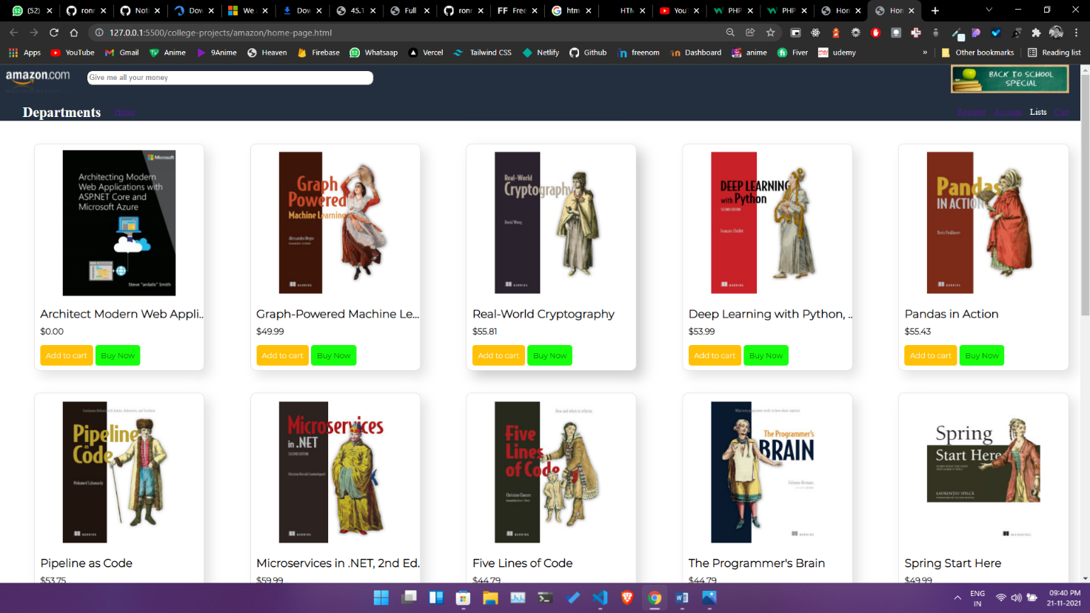

**Registration>**

<!DOCTYPE html>

<html lang="en">

<head>

    <meta charset="UTF-8">

    <meta http-equiv="X-UA-Compatible" content="IE=edge">

    <meta name="viewport" content="width=device-width, initial-scale=1.0">

    <title>Registration Form</title>

    <link rel="stylesheet" href="./css/home.css">

     <link rel="stylesheet" href="./css/registration.css">

      <link rel="stylesheet" href="https://stackpath.bootstrapcdn.com/bootstrap/4.1.3/css/bootstrap.min.css"

        integrity="sha384-MCw98/SFnGE8fJT3GXwEOngsV7Zt27NXFoaoApmYm81iuXoPkFOJwJ8ERdknLPMO" crossorigin="anonymous">

</head>

<body>

 <div id='navBar'>

  <div id='topHalf'>

    <div id='logoWrapper'>

    <img id='logo' src="http://www.userlogos.org/files/logos/ArkAngel06/Amazon.png" />

    </div>

    <input type="text" placeholder="Give me all your money" />

    <img id='backToSchool' src="http://blog.neurogistics.com/wp-content/uploads/2014/08/Back-To-School-Special-Banner.jpg" alt="" />

  </div>

  <nav id='bottomHalf'>

    <div id='department'>Departments</div>

    <div id='sections'>

       <a href="./home-page.html" class="section">Home</a>

    </div>

    <div id='accountStuff'>

      <a href="./registration-form.html" class="section">Your Account</a>

      <div class="section">Try Prime</div>

      <div class="section">Lists</div>

      <div class="section">Cart</div>

    </div>

  </link>

</div>

<div class="form_wrapper">

  <div class="form_container">

    <div class="title_container">

      <h2>Create An Account</h2>

    </div>

    <div class="row clearfix">

      <div class="">

        <form>

          <div class="input_field">

            <input type="email" name="email" placeholder="Email" required />

          </div>

          <div class="input_field">

            <input type="password" name="password" placeholder="Password" required />

          </div>

          <div class="input_field">

            <input type="password" name="password" placeholder="Re-type Password" required />

          </div>

          <div class="row clearfix">

            <div class="col_half">

              <div class="input_field">

                <input type="text" name="name" placeholder="First Name" />

              </div>

            </div>

            <div class="col_half">

              <div class="input_field">

                <input type="text" name="name" placeholder="Last Name" required />

              </div>

            </div>

          </div>

              <div class="input_field radio_option">

              <input type="radio" name="radiogroup1" id="rd1">

              <label for="rd1">Male</label>

              <input type="radio" name="radiogroup1" id="rd2">

              <label for="rd2">Female</label>

              </div>

              <div class="input_field select_option">

                <select>

                  <option>Select a country</option>

                  <option>India</option>

                  <option>Nepal</option>

                </select>

                <div class="select_arrow"></div>

              </div>

            <div class="input_field checkbox_option">

              <input type="checkbox" id="cb1">

          <label for="cb1">I agree with terms and conditions</label>

            </div>

          <input class="button" type="submit" value="Register" />

          <a href="./login-form.html">already have an account</a>

        </form>

      </div>

    </div>

  </div>

</div></body></html>

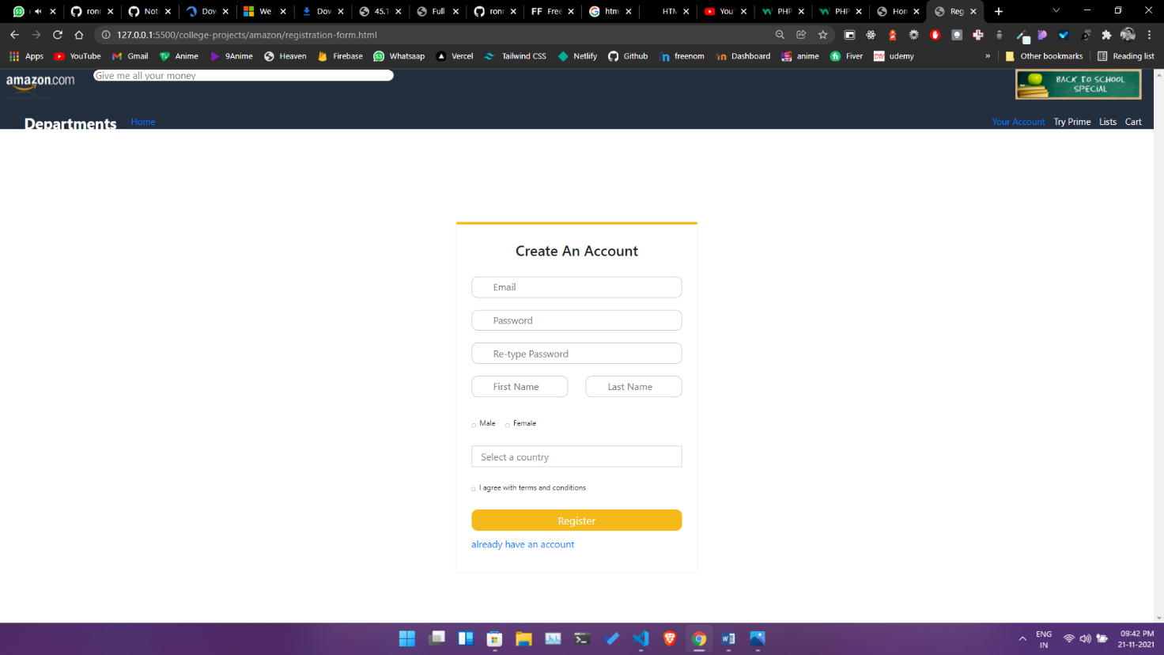

**Login Page>**

<!DOCTYPE html>

<html lang="en">

<head>

    <meta charset="UTF-8">

    <meta http-equiv="X-UA-Compatible" content="IE=edge">

    <meta name="viewport" content="width=device-width, initial-scale=1.0">

    <title>Registration Form</title>

    <link rel="stylesheet" href="./css/home.css" />

    <link rel="stylesheet" href="./css/login.css">

    <link rel="stylesheet" href="https://stackpath.bootstrapcdn.com/bootstrap/4.1.3/css/bootstrap.min.css"

        integrity="sha384-MCw98/SFnGE8fJT3GXwEOngsV7Zt27NXFoaoApmYm81iuXoPkFOJwJ8ERdknLPMO" crossorigin="anonymous">

</head>

<body>

    <div id='navBar'>

        <div id='topHalf'>

            <div id='logoWrapper'>

                <img id='logo' src="http://www.userlogos.org/files/logos/ArkAngel06/Amazon.png" />

            </div>

            <input type="text" placeholder="Give me all your money" />

            <img id='backToSchool'

                src="http://blog.neurogistics.com/wp-content/uploads/2014/08/Back-To-School-Special-Banner.jpg"

                alt="" />

        </div>

        <nav id='bottomHalf'>

            <div id='department'>Departments</div>

            <div id='sections'>

                <a href="./home-page.html" class="section">Home</a>

            </div>

            <div id='accountStuff'>

                <a href="./registration-form.html" class="section">Your Account</a>

                <div class="section">Try Prime</div>

                <div class="section">Lists</div>

                <div class="section">Cart</div>

            </div>

            </link>

    </div>

    <header>

        <!--Amazon Image Logo-->

        <div class="d-flex flex-row justify-content-center">

            <div class="row">

                <div class="col-md">

                    <img class="img_1"

                        src="https://w7.pngwing.com/pngs/928/468/png-transparent-canada-amazon-com-california-amazon-drive-amazon-prime-adidas-logo-s-text-service-canada.png"

                        alt="Amazon Logo" />

                </div>

                <!--Col 1 End-->

            </div>

            <!--Row 1 End-->

        </div>

        <!--Container End-->

        <!--Amazon Image Logo-->

    </header>

    <div class="d-flex flex-row justify-content-center">

        <div class="row">

            <div class="col-md">

                <form>

                    <div class="sign-in">Sign In</div>

                    <div class="form-group">

                        <label id="words_1" for="exampleInputEmail1">Email(phone for mobile accounts)</label>

                        <input type="email" class="form-control" id="exampleInputEmail1" aria-describedby="emailHelp"

                            placeholder="Enter email">

                        <small id="emailHelp" class="form-text text-muted"></small>

                    </div>

                    <div class="form-group">

                        <label id="words_2" for="exampleInputPassword1">Password &nbsp &nbsp &nbsp &nbsp &nbsp &nbsp

                            &nbsp &nbsp &nbsp &nbsp &nbsp &nbsp &nbsp &nbsp &nbsp &nbsp &nbsp &nbsp Forgot your

                            password? </label>

                        <input type="password" class="form-control" id="exampleInputPassword1" placeholder="Password">

                        <div class="form-group">

                            <button type="button" class="btn btn-warning" id="sign-in">Sign In</button>

                            <br />

                            <button type="button" class="btn btn-warning" id="grey-button">Create your Amazon

                                account</button>

                        </div>

                    </div>

                    <div class="form-check">

                        <p class="keep-sign-in text-center"><a href="./registration-form.html">Don't have an account

                            </a></p>

                    </div>

                </form>

            </div>

            <!--Col 1 End-->

        </div>

        <!--Row 1 End-->

    </div>

    <!--Container End-->

    <!--Form-->

    <div class="d-flex flex-row justify-content-center footer_1">

        <div class="row">

            <div class="col">

                <p class="conditions"><a>Conditions of Use &nbsp &nbsp &nbsp </a> <a>Privacy Notice&nbsp &nbsp &nbsp

                    </a> <a>Help&nbsp &nbsp &nbsp </a></p>

            </div>

        </div>

    </div>

</body>

</html>

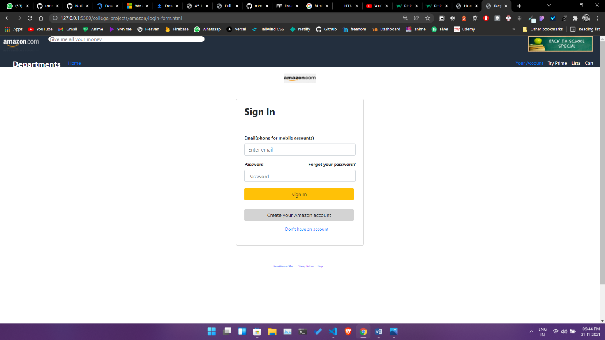

**Profile>**

<!DOCTYPE html>

<html lang="en">

<head>

    <meta charset="UTF-8">

    <meta http-equiv="X-UA-Compatible" content="IE=edge">

    <meta name="viewport" content="width=device-width, initial-scale=1.0">

    <title>Profile</title>

    <link rel="stylesheet" href="./css/home.css"/>

    <link rel="stylesheet" href="./css/profile.css">

    <link rel="stylesheet" href="https://cdn.jsdelivr.net/npm/bootstrap@5.0.0-beta1/dist/css/bootstrap.min.css">

</head>

<body>

      <div id='navBar'>

  <div id='topHalf'>

    <div id='logoWrapper'>

    <img id='logo' src="http://www.userlogos.org/files/logos/ArkAngel06/Amazon.png" />

    </div>

    <input type="text" placeholder="Give me all your money" />

    <img id='backToSchool' src="http://blog.neurogistics.com/wp-content/uploads/2014/08/Back-To-School-Special-Banner.jpg" alt="" />

  </div>

  <nav id='bottomHalf'>

    <div id='department'>Departments</div>

    <div id='sections'>

    <a href="./home-page.html" class="section">Home</a>

    </div>

    <div id='accountStuff'>

      <a href="./registration-form.html" class="section">Your Account</a>

      <a href="./profile.html" class="section">Account</a>

      <div class="section">Lists</div>

      <div class="section">Cart</div>

    </div>

</div>

</div>

<div class="container mt-4 mb-4 p-3 d-flex justify-content-center">

    <div class="card p-4">

        <div class=" image d-flex flex-column justify-content-center align-items-center"> <button class="btn btn-secondary"> <img src="./assets/page.png" height="100" width="100" /></button> <span class="name mt-3">User</span> <span class="idd">@xyz</span>

             <div class="d-flex flex-row justify-content-center align-items-center mt-3"> <span class="number">1069 <span class="follow">Books read</span></span> </div>

            <div class=" d-flex mt-2"> <button class="btn1 btn-dark">Edit Profile</button> </div>

            <div class="gap-3 mt-3 icons d-flex flex-row justify-content-center align-items-center"> <span><i class="fa fa-twitter"></i></span> <span><i class="fa fa-facebook-f"></i></span> <span><i class="fa fa-instagram"></i></span> <span><i class="fa fa-linkedin"></i></span> </div>

            <div class=" px-2 rounded mt-4 date "> <span class="join">Joined May,2021</span> </div>

        </div>

    </div>

</div>

</body>

</html>

**Output>**

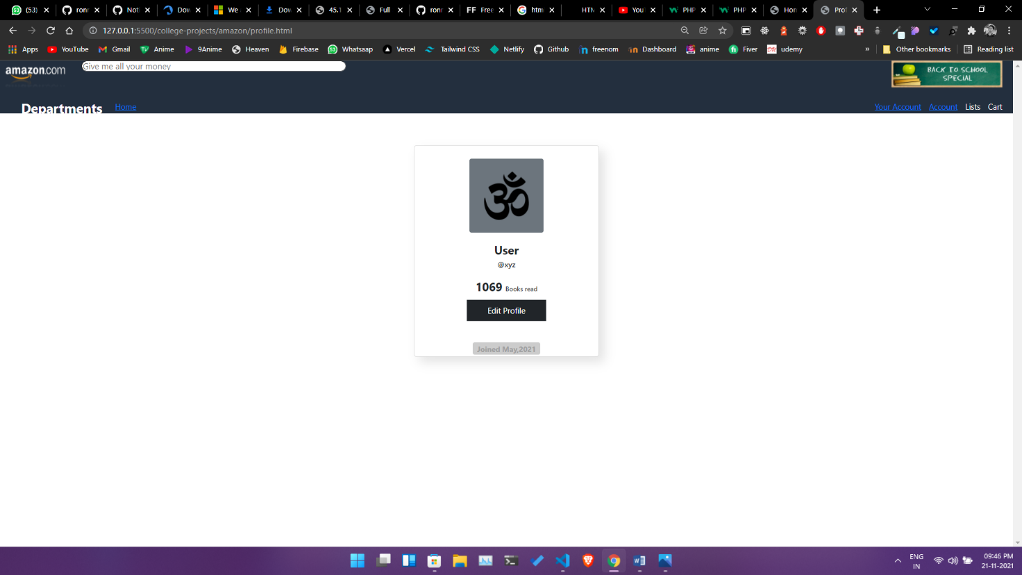

**Css>**

**Home.css**

@import url('https://fonts.googleapis.com/css2?family=Montserrat:wght@300&display=swap');

body{

    padding: 0;

    margin: 0;

    overflow-y: scroll ;

    overflow-x: hidden;

}

#navBar{

  background-color:#232F3E;

  height:100px;

  color:white

}

#topHalf{

  height:50px;

}

#bottomHalf{

  height:50px

}

#logo{

  height:100px;

  position:absolute;

  top:-25px

}

#logoWrapper{

  margin-bottom:20px;

  display:inline-block;

  position:relative;

  width:150px;

}

#backToSchool{

  height:50px;

  float:right;

  margin-right:20px

}

input{

  vertical-align:top;

  margin-top:10px;

  border-radius:10px;

  height:20px;

  width:500px;

}

#department{

  font-size:25px;

  padding:10px;

  margin-left:30px;

  font-weight:bold;

  display:inline-block;

  vertical-align:top;

  margin-top:10px

}

#sections{

  display:inline-block

}

.section{

  display:inline-block;

  vertical-align:top;

  font-size:15px;

  margin-top:25px;

  margin-left:10px

}

#accountStuff{

  display:inline-block;

  float:right;

  margin-right:20px

}

.container{

  margin-top:20px;

  margin-left:20px;

  margin-right:20px;

}

.main{

  margin:20px;

  display:inline-block;

  vertical-align:top;

  width:100%;

  height:100%;

  background-color:white;

}

.flex{

    display:flex;

    flex-direction:row;

    flex-wrap:wrap;

    justify-content:space-around;

    align-items:center;

    margin-top:20px;

    margin-left:20px;

    margin-right:20px;

    }

    .card{

      width:300px;

      height:400px;

   border-radius: 50px;

background: #ffffff;

box-shadow:  10px 10px 20px #e3e3e3,

             -10px -10px 20px #ffffff;

      margin:20px;

      cursor: pointer;

      border-radius:10px;

      overflow:hidden;

    transition:  0.2s;

    border:1px solid #e3e3e3;

    }

.card:hover{

box-shadow:  12px 12px 24px #cccccc,

             -12px -12px 24px #ffffff;

}

.card-image {

  width:100%;

  object-fit: cover;

  max-height:280px;

border-radius:10px;

}

.card-content{

  padding: 5px 10px;

  height:100px;

  overflow:hidden;

}

.card-title{

  font-size:20px;

  font-weight:bold;

 font-family: 'Montserrat', sans-serif; margin: 0;

  white-space: nowrap;

  overflow: hidden;

  text-overflow: ellipsis;

  width: 300px

}

.card-price{

  font-size:15px;

  font-weight:bold;

  margin:0 ,5px;

  margin-top:10px;

  font-family: 'Montserrat', sans-serif;

}

.add-to-cart{

  background-color:#FFC107;

    color:white;

    font-family: 'Montserrat', sans-serif;

    text-align: center;

    padding: 10px;

    border: 0;

    cursor: pointer;

    border-radius:5px;

}

.buy-now{

  background-color:#16ff0e;

    font-family: 'Montserrat', sans-serif;

    text-align: center;

    padding: 10px;

    border: 0;

    cursor: pointer;

    border-radius:5px;

}

**Login/register Css.**

body {

     font-family: Verdana, Geneva, sans-serif;

     font-size: 14px;

     background: #f2f2f2;

}

 .clearfix:after {

     content: "";

     display: block;

     clear: both;

     visibility: hidden;

     height: 0;

}

 .form_wrapper {

     background: #fff;

     width: 400px;

     max-width: 100%;

     box-sizing: border-box;

     padding: 25px;

     margin: 8% auto 0;

     position: relative;

     z-index: 1;

     border-top: 5px solid #f5ba1a;

     -webkit-box-shadow: 0 0 3px rgba(0, 0, 0, 0.1);

     -moz-box-shadow: 0 0 3px rgba(0, 0, 0, 0.1);

     box-shadow: 0 0 3px rgba(0, 0, 0, 0.1);

}

 .form_wrapper h2 {

     font-size: 1.5em;

     line-height: 1.5em;

     margin: 0;

}

 .form_wrapper .title_container {

     text-align: center;

     padding-bottom: 15px;

}

 .form_wrapper h3 {

     font-size: 1.1em;

     font-weight: normal;

     line-height: 1.5em;

     margin: 0;

}

 .form_wrapper label {

     font-size: 12px;

}

 .form_wrapper .row {

     margin: 10px -15px;

}

 .form_wrapper .row > div {

     padding: 0 15px;

     box-sizing: border-box;

}

 .form_wrapper .col_half {

     width: 50%;

     float: left;

}

 .form_wrapper .input_field {

     position: relative;

     margin-bottom: 20px;

}

 .form_wrapper input[type="text"], .form_wrapper input[type="email"], .form_wrapper input[type="password"] {

     width: 100%;

     padding: 8px 10px 9px 35px;

     height: 35px;

     border: 1px solid #ccc;

     box-sizing: border-box;

     outline: none;

     -webkit-transition: all 0.3s ease-in-out;

     -moz-transition: all 0.3s ease-in-out;

     -ms-transition: all 0.3s ease-in-out;

     transition: all 0.3s ease-in-out;

}

 .form_wrapper input[type="submit"] {

     background: #f5ba1a;

     height: 35px;

     line-height: 35px;

     width: 100%;

     border: none;

     outline: none;

     cursor: pointer;

     color: #fff;

     font-size: 1.1em;

     margin-bottom: 10px;

     -webkit-transition: all 0.3s ease-in-out;

     -moz-transition: all 0.3s ease-in-out;

     -ms-transition: all 0.3s ease-in-out;

     transition: all 0.3s ease-in-out;

}

 .form_wrapper input[type="submit"]:hover {

     background: #e1a70a;

}

 .form_wrapper input[type="checkbox"], .form_wrapper input[type="radio"] {

     border: 0;

     clip: rect(0 0 0 0);

     height: 1px;

     margin: -1px;

     overflow: hidden;

     padding: 0;

     position: absolute;

     width: 1px;

}

 .form_container .row .col_half.last {

     border-left: 1px solid #ccc;

}

 .checkbox_option label {

     margin-right: 1em;

     position: relative;

}

 .checkbox_option label:before {

     content: "";

     display: inline-block;

     width: 0.5em;

     height: 0.5em;

     margin-right: 0.5em;

     vertical-align: -2px;

     border: 2px solid #ccc;

     padding: 0.12em;

     background-color: transparent;

     background-clip: content-box;

     transition: all 0.2s ease;

}

 .checkbox_option label:after {

     border-right: 2px solid #000;

     border-top: 2px solid #000;

     content: "";

     height: 20px;

     left: 2px;

     position: absolute;

     top: 7px;

     transform: scaleX(-1) rotate(135deg);

     transform-origin: left top;

     width: 7px;

     display: none;

}

 .checkbox_option input:hover + label:before {

     border-color: #000;

}

 .checkbox_option input:checked + label:before {

     border-color: #000;

}

 .checkbox_option input:checked + label:after {

     -moz-animation: check 0.8s ease 0s running;

     -webkit-animation: check 0.8s ease 0s running;

     animation: check 0.8s ease 0s running;

     display: block;

     width: 7px;

     height: 20px;

     border-color: #000;

}

 .radio_option label {

     margin-right: 1em;

}

 .radio_option label:before {

     content: "";

     display: inline-block;

     width: 0.5em;

     height: 0.5em;

     margin-right: 0.5em;

     border-radius: 100%;

     vertical-align: -3px;

     border: 2px solid #ccc;

     padding: 0.15em;

     background-color: transparent;

     background-clip: content-box;

     transition: all 0.2s ease;

}

 .radio_option input:hover + label:before {

     border-color: #000;

}

 .radio_option input:checked + label:before {

     background-color: #000;

     border-color: #000;

}

 .select_option {

     position: relative;

     width: 100%;

}

 .select_option select {

     display: inline-block;

     width: 100%;

     height: 35px;

     padding: 0px 15px;

     cursor: pointer;

     color: #7b7b7b;

     border: 1px solid #ccc;

     border-radius: 0;

     background: #fff;

     appearance: none;

     -webkit-appearance: none;

     -moz-appearance: none;

     transition: all 0.2s ease;

}

 .select_option select::-ms-expand {

     display: none;

}

 .select_option select:hover, .select_option select:focus {

     color: #000;

     background: #fafafa;

     border-color: #000;

     outline: none;

}

 .credit {

     position: relative;

     z-index: 1;

     text-align: center;

     padding: 15px;

     color: #f5ba1a;

}

 .credit a {

     color: #e1a70a;

}

**NAME** – Siddharth Kumar **Roll** **number**: 1922065

**COURSE**: - B. Sc(IT). **Subject** **code**: PBI-502

**SUBJECT**: Full Stack Development **Semester**-5th

**University** Id: 19051056

**PROBLEM STATEMENT - 29** Write a program to demonstrate the image mapping.

**OBJECTIVE :** To learn how to create links with pictures.

**DESCRIPTION :**

**Tag used –**

<img>

<map>

**SOURCE CODE:**

<!DOCTYPE html>

<html lang="en">

<head>

    <meta charset="UTF-8">

    <meta http-equiv="X-UA-Compatible" content="IE=edge">

    <meta name="viewport" content="width=device-width, initial-scale=1.0">

    <title>Image Mapping</title>

</head>

<body>

    <h1>Image Mapping</h1>

    <img src="./assets/car.jpg" alt="Workplace" usemap="#imageMap" >

<map name="imageMap">

 <area  alt="Car" title="Car" href="https://www.ford.com/cars/mustang/" target="_blank"  coords="652,968,2,439" shape="rect">

 <area target="_blank" alt="New_York_City" title="City" href="https://en.wikipedia.org/wiki/New_York_City" coords="660,216,1895,620" shape="rect">

</map>

</body>

</html>

**Output**

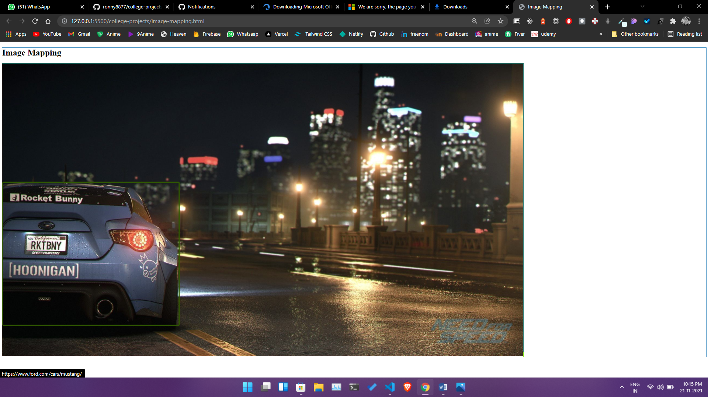

**NAME** – Siddharth Kumar **Roll** **number**: 1922065

**COURSE**: - B. Sc(IT). **Subject** **code**: PBI-502

**SUBJECT**: Full Stack Development **Semester**-5th

**University** Id: 19051056

**PROBLEM STATEMENT - 6 :** Design your time-table using all the table tags along with its attributes.

**OBJECTIVE :** To understand how to design the tabular data in html document which is in the format of rows and columns for example :- making a time table.

**DESCRIPTION :**

**Tag used –**

<table>

<tr>

<td>

**Source Code :**

<!DOCTYPE html>

<html lang="en">

<head>

    <meta charset="UTF-8">

    <meta http-equiv="X-UA-Compatible" content="IE=edge">

    <meta name="viewport" content="width=device-width, initial-scale=1.0">

    <title>Document</title>

</head>

<body>

    <center><h1>TIME TABLE</h1></center>

    <table border="5" cellspacing="0" align="center">

        <tr>

            <td align="center" height="50"

                width="100"><br>

                <b>Day/Period</b></br>

            </td>

            <td align="center" height="50"

                width="100">

                <b>I<br>9:00-9:55</b>

            </td>

            <td align="center" height="50"

                width="100">

                <b>II<br>10:00-10:50</b>

            </td>

            <td align="center" height="50"

                width="100">

                <b>III<br>11:00-11:55</b>

            </td>

            <td align="center" height="50"

                width="100">

                <b>12:05-01:00</b>

            </td>

            <td align="center" height="50"

                width="100">

                <b>IV<br>01:00-1:55</b>

            </td>

            <td align="center" height="50"

                width="100">

                <b>V<br>1:55-2:50</b>

            </td>

            <td align="center" height="50"

                width="100">

                <b>VI<br>3:10-4:05</b>

            </td>

            <td align="center" height="50"

                width="100">

                <b>VII<br>4:05-5:00</b>

            </td>

        </tr>

        <tr>

            <td align="center" height="50">

                <b>Monday</b></td>

            <td align="center" height="50">TBI501</td>

            <td align="center" height="50">TBI503</td>

            <td align="center" height="50">TBI502</td>

            <td align="center" height="50">TBI504</td>

            <td rowspan="6" align="center" height="50">

                <h2>L<br>U<br>N<br>C<br>H<br><br>B<br>R<br>E<br>A<br>K</h2>

            </td>

            <td ></td>

            <td ></td><td ></td>

        </tr>

        <tr>

            <td align="center" height="50">

                <b>Tuesday</b>

            </td>

            </td>

            <td align="center" height="50">TBI503</td>

            <td align="center" height="50">TBI501</td>

            <td align="center" height="50">TBI501</td>

            <td align="center" height="50">TBI504</td>

            <td align="center" colspan="3"> LAB PBI502</td>

        </tr>

        <tr>

            <td align="center" height="50">

                <b>Wednesday</b>

            </td>

            <td align="center" height="50">TBI502</td>

            <td align="center" height="50">TBI503</td>

            <td align="center" height="50">TBI501</td>

            <td align="center" height="50">TBI504</td>

            <td colspan="3" align="center"

                height="50">LAB PBI503

            </td>

        </tr>

        <tr>

            <td align="center" height="50">

                <b>Thursday</b>

            </td>

            <td align="center" height="50">XBI501</td>

            <td align="center" height="50">TBI502</td>

            <td align="center" height="50">TBI503</td>

            <td align="center" height="50">SBI501</td>

            <td></td><td></td><td></td>

        </tr>

        <tr>

            <td align="center" height="50">

                <b>Friday</b>

            </td>

            </td>

            <td align="center" height="50"></td>

            <td align="center" height="50"></td>

            <td align="center" height="50"></td>

            <td align="center" height="50"></td>

            <td></td><td></td><td></td>

        </tr>

        <tr>

            <td align="center" height="50">

                <b>Saturday</b>

            </td>

            <td align="center" height="50"></td>

            <td align="center" height="50"></td>

            <td align="center" height="50"></td>

            <td></td><td></td>

            <td></td>

        </tr>

    </table>

    <table  border="3" cellspacing="0" align="center">

        <tr>

            <td align="center" height="30" width="100">

                <b>CODE</b>

            </td>

            <td align="center" height="50"width="400">

                <b>SUBJECT</b></td>

            <td align="center" height="50"width="300">

                    <b>FACULTY</b></td>

            <td align="center" height="50"width="120">

                        <b>L T P C</b></td>

        </tr>

        <tr>

            <td align="center" height="20" width="100">TBI501</td>

            <td align="center" height="20" width="100">MOBILE APPLICATION DEVELOPMENT</td>

            <td align="center" height="20" width="100">MS ATIKA GUPTA</td>

            <td align="center" height="20" width="100">3 0 0 3</td>

        </tr>

        <tr>

            <td align="center" height="20" width="100">TBI502</td>

            <td align="center" height="20" width="100">FULL STACK DEVELOPMENT</td>

            <td align="center" height="20" width="100">MS DEEPIKA SHARMA</td>

            <td align="center" height="20" width="100">3 0 0 3</td>

        </tr>

        <tr>

            <td align="center" height="20" width="100">TBI503</td>

            <td align="center" height="20" width="100">CLOUD COMPUTING</td>

            <td align="center" height="20" width="100">MS DIVYA KAPIL</td>

            <td align="center" height="20" width="100">3 1 0 4</td>

        </tr>

        <tr>

            <td align="center" height="20" width="100">TBI504</td>

            <td align="center" height="20" width="100">SOFTWARE ENGINEERING</td>

            <td align="center" height="20" width="100">MS NIDHI MEHRA</td>

            <td align="center" height="20" width="100">3 0 0 3</td>

        </tr>

        <tr>

            <td align="center" height="20" width="100">XBI501</td>

            <td align="center" height="20" width="100">CARREER SKILLS III</td>

            <td align="center" height="20" width="100">MS SULEKHA</td>

            <td align="center" height="20" width="100">2 0 0 2</td>

        </tr>

        <tr>

            <td align="center" height="20" width="100">PBI501</td>

            <td align="center" height="20" width="100">MOBILE APPLICATION DEVELOPMENT LAB</td>

            <td align="center" height="20" width="100">MS ATIKA GUPTA</td>

            <td align="center" height="20" width="100">0 0 4 2</td>

        </tr>

        <tr>

            <td align="center" height="20" width="100">PBI502</td>

            <td align="center" height="20" width="100">FULL STACK DEVELOPMENT LAB</td>

            <td align="center" height="20" width="100">MS DEEPIKA</td>

            <td align="center" height="20" width="100">3 0 0 3</td>

        </tr>

        <tr>

            <td align="center" height="20" width="100">SB1501</td>

            <td align="center" height="20" width="100">SEMINAR</td>

            <td align="center" height="20" width="100">MS NIDHI</td>

            <td align="center" height="20" width="100">0 0 4 1</td>

        </tr>

    </table>

</body></html>

**Output**

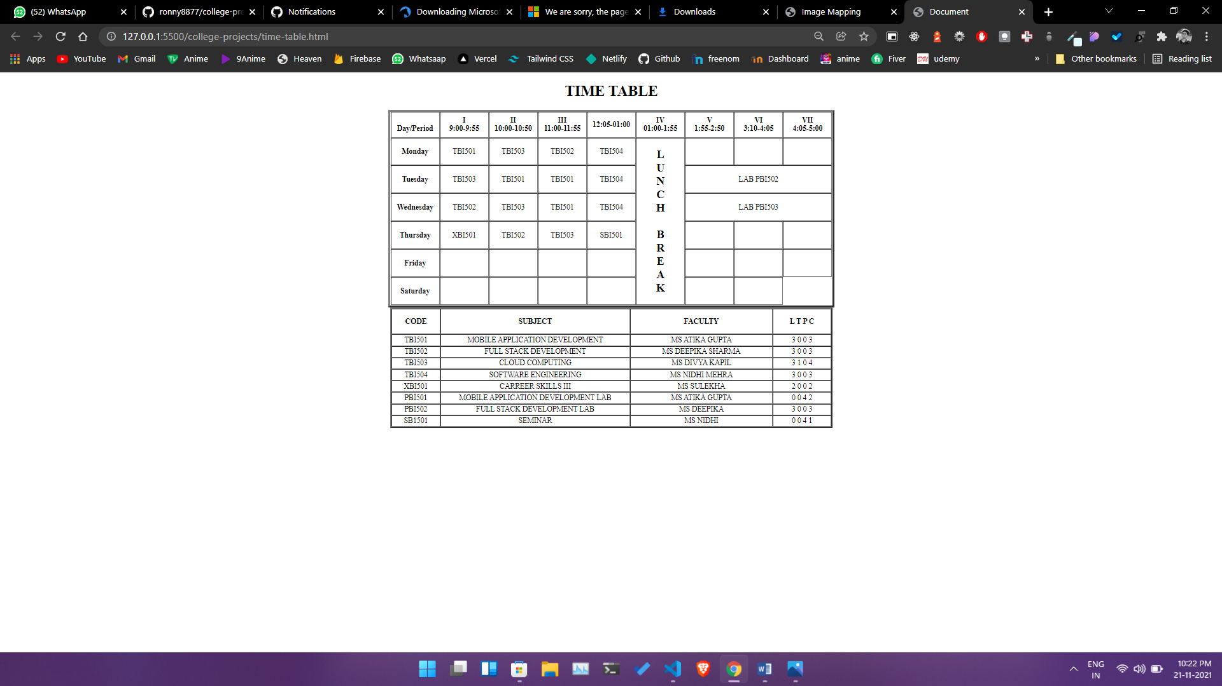

**NAME** – Siddharth Kumar **Roll** **number**: 1922065

**COURSE**: - B. Sc(IT). **Subject** **code**: PBI-502

**SUBJECT**: Full Stack Development **Semester**-5th

**University** Id: 19051056

**PROBLEM STATEMENT - 7:** Create the table using appropriate tags:

**OBJECTIVE :** To understand how to design the tabular data in html document which is in the format of rows and columns.

**DESCRIPTION :**

**Tag used –**

**<table>: It defines the HTML table.**

**<tr>: It defines the table row.**

**<th>: It defines the table header.**

**<td>: It defines the able cell.**

**<caption>: It defines the title of a table in the HTML document**

**SOURCE CODE:**

<html>

<head>

<title> table></title>

<style type="text/css">

table{

border: 1px solid black;

}

td{

border:1px solid black;

}

</style>

</head>

<body>

<table>

<thead>

<th>owners name</th>

<th>dogs name</th>

<th>breed</th>

</thead>

<tr>

<td>

paridhi</td>

<td> milo</td>

<td>pugaso</td>

</tr>

<tr>

<td>

ashu</td>

<td> tippi</td>

<td>street</td>

</tr>

<tr>

<td>

Siddharth</td>

<td> Scout</td>

<td>Indian spitz</td>

</tr>

<tr></body> </html>

